|  |
| --- |
| Name: GPDCM Jayasekara |
| Student Reference Number: 10707085 |



|  |  |
| --- | --- |
| Module Code: ISAD253SL | Module Name: Databases |
| Coursework Title: Group Assignment | |
| Deadline Date: Monday, 4 January 2021 | Member of staff responsible for coursework:  Mr. Naji Saravanabavan |
| Programme: BSc (Honours) Software Engineering / BSc (Honours) Computer Networks /  BSc (Honours) Computer Security | |
| Please note that University Academic Regulations are available under Rules and Regulations on the University website [www.plymouth.ac.uk/studenthandbook](http://www.plymouth.ac.uk/studenthandbook). | |
| Group work: please list all names of all participants formally associated with this work and state whether the work was undertaken alone or as part of a team. Please note you may be required to identify individual responsibility for component parts.   |  |  |  |  |  |  |  | | --- | --- | --- | --- | --- | --- | --- | | **Member Activity** | **Member 01 ID: 10707085** | **Member 02 ID: 10707385** | **Member 03 ID: 10707372** | **Member 04 ID: 10707241** | **Member 05 ID: 10707052** | **Member 06 ID: 10707** | | **Book Table** |  |  |  |  |  |  | | **Borrower Table** |  |  |  |  |  |  | | **Copy Table** |  |  |  |  |  |  | | **Issue-Info Table** |  |  |  |  |  |  | | **Publisher Table** |  |  |  |  |  |  | | **Library Table** |  |  |  |  |  |  | | **Staff & Authentication System** |  |  |  |  |  |  |   ***We confirm that we have read and understood the Plymouth University regulations relating to Assessment Offences and that we are aware of the possible penalties for any breach of these regulations. We confirm that this is the independent work of the group.***  Signed on behalf of the group: A picture containing diagram  Description automatically generated | |
| Individual assignment: ***I confirm that I have read and understood the Plymouth University regulations relating to Assessment Offences and that I am aware of the possible penalties for any breach of these regulations. I confirm that this is my own independent work.***  Signed: | |
| Use of translation software: failure to declare that translation software or a similar writing aid has been used will be treated as an assessment offence.  I *have used/not used translation software.  If used, please state name of software………………………………………………………………… | |
| **Overall mark _____% Assessors Initials ______ Date_________** | |
|  | |

*Please delete as appropriateSci/ps/d:/students/cwkfrontcover/2013/14

**LIBRARY MANAGEMENT SYSTEM**

Table of Contents

1. SECTION 01 6

❖ INTRODUCTION TO THE SCENARIO LIBRARY MANAGEMENT SYSTEM 7

❖ EXTENDED ENTITY RELATIONSHIP DIAGRAM 7

❖ ASSUMPTIONS MADE REGARDING THE EERD 9

❖ RELATIONAL MAPPING 11

❖ NORMALIZATION 12

1) BOOK TABLE 12

2) BORROWER TABLE 13

3) COPY TABLE 13

4) ISSUEINFO TABLE 14

❖ DATA DICTIONARY 14

2. SECTION 02 15

❖ CREATE TABLES AND CONSTRAINTS 15

1) BOOK TABLE 16

2) BORROWER TABLE 16

3) COPY TABLE 17

1. Create table and use constraints. 17

4) ISSUE-INFO TABLE 18

1. Create table and use constraints. 18

❖ DB DIAGRAMS 19

❖ SAMPLE RECORDS 20

3) COPY TABLE 22

1. Insert sample data 22

2. Table of ‘Copy’ sample data in C#. 23

4) ISSUE-INFO TABLE 24

1. Insert sample data 24

2. Table of ‘IssueInfo’ sample data in C#. 24

3. SECTION 03 25

❖ TRIGGERS 25

1) BOOK TABLE 25

2) BORROWER TABLE 25

3) COPY TABLE 25

1. After Update Trigger 26

1. After Delete Trigger 26

4) ISSUE-INFO TABLE 27

1. Insert trigger 28

2. Delete trigger 28

3. Update trigger. 29

❖ DATABASE VIEWS 30

1) BOOK TABLE 31

2) BORROWER TABLE 31

3) COPY TABLE 31

1. Create View 32

2. Create View 32

4) ISSUE-INFO TABLE 32

3. Create View 33

4. Create View 33

❖ USER DEFINED FUNCTIONS 33

1) BOOK TABLE 34

2) BORROWER TABLE 34

3) COPY TABLE 34

1. Create SQL Scalar Functions. 35

2. Create SQL Scalar Functions. 35

4) ISSUE-INFO TABLE 35

1. Create SQL Scalar Functions. 36

2. Create SQL Scalar Functions. 36

❖ STORED PROCEDURES 38

1) BOOK TABLE 38

2) BORROWER TABLE 38

3) COPY TABLE 38

1. Select Stored Procedure. 39

2. Update Stored Procedure. 41

4) ISSUE-INFO TABLE 44

1. Select Stored Procedure. 44

2. Update Stored Procedure. 47

4. SECTION 04 48

❖ CRITICAL EVALUVATION 48

❖ FUTURE IMPLEMENTATION 50

5. LIBRARY MANAGEMENT SYSTEM – INTERFACES 51

1) LOGIN INTERFACE 51

2) BACKGROUND INTERFACE 53

3) BOOK INTERFACE 53

4) BORROWER INTERFACE 54

5) ISSUE-BOOK INTERFACE 55

❖ HOW IT WORKS? 55

❖ ERROR MESSAGES 60

# SECTION 01

# INTRODUCTION TO THE SCENARIO LIBRARY MANAGEMENT SYSTEM

A library service wants to create a database to store details of its libraries, books, borrowers, publishers, and staff. Details include the following: A book has a unique ISBN number, a title, published date, book name, category, and authors. The library service may own several copies of a given book, each of which is located in one of the service’s libraries. A given library contains many books, and in order to distinguish different copies of the same book a library assigns a different copy-number to each of its copies of a given book; the price that was paid for each copy is also recorded. For every book which has been issued with a unique issue number along with a fine, issue date and return date. If a borrower does not return the book in a duration of 14 days then, a fine is calculated based on the extra days. A borrower has a name, a unique ID code along with a unique NIC, email, phone, district, city, membership date, membership expire date. A borrower can have many books on loan, but each copy of a book can only be on loan to one borrower. A borrower could borrow the same book on several occasions, but it is assumed that each such loan will take place on a different date. Each publisher has a unique publisher ID, publisher name, published date and a published country. Each publisher has a unique contact number, and each publisher publishes only one book. Every library has a unique library code along with a library branch name, branch address and library types, the number of copies issued to a library is also recorded and is either a main library or a branch library. A main library may have zero or more branch libraries and every branch library is a branch of exactly one main library. Every Staff member has a staff id. Every staff member are not administrators. Admin can view all the information about staff members. Only admin can enter the details of staff members into database, but staff can't do their own. An admin can add new staff members, delete, grant/revoke access to database, track borrowers' details and maintain details of resources available in premises. Only admins can login into the systems with their own passwords and username.

# EXTENDED ENTITY RELATIONSHIP DIAGRAM



# ASSUMPTIONS MADE REGARDING THE EERD

* A book can have one or more authors (B_Author)
* The name published date and category of the book is also additionally recorded
* A borrower can have one or more phone numbers (M_Phone)
* A borrower’s address (M_Address) consist of 2 parts city (M_City) & district (M_District), his\hers address can be null.
* A borrower’s name (M_Name) consist of 2 parts first name (M_Fname) & second name (M_Lname).
* A borrower’s unique NIC (M_NIC), unique email (M_Email), start of membership date (M_Date) and membership expiry date (M_Expiry) is also recorded as it provides clear information and to properly identify the borrower.
* Added IssueInfo table to save issued books data.
* An IssueInfo table attributes are Issue number (IssueNo- which is increment automatically), Fine, Issue date (IssueDate), Return date (ReturnDate).
* A Library can have a main with many branches or no branches however a branch cannot be created without a main (Library) (main) (branch)
* Each library should have a name which is not null (BranchName)
* Further the number of copies recieved to each branch is recorded (CopyNumber)
* Assuming that there are many types of libraries the following attributes are additionally created (public)(private)(school) are broken down by the relationship from the (branch)
* (BranchAddress) is created assuming that each library has an address which is not null since it is compulsory.
* After considering the above scenario we have added two adiitional attributes of published city (Pub_City) and publisher E-mail (Pub_Email) inorder to provide more information about the publisher.
* Publisher ID (Pub_ID) is the primary key.
* We assume that publisher contact (Pub_Contact) and publisher e-mail (Pub_Email) addresses are not multi-valued attributes and can record only one value for each of the publisher data input
* Staff entity has attributes named, Name, Contact, Email, StaffID (primary key which is set to incremented) and Staff Role
* Staff members are required for library to check status of resources.
* StaffID is the primary key for staff members as it helps to uniquely identify each single member.
* Staff members who want log into the system are required to provide the valid username and password. Using username and password can prevent unauthorized parties to login the system.
* Staff members who have thier role set to admin are considered as administrators and only them can login the system.
* Name of the staff members are breaked into first and last name in separate fields to identify easily.
* Contact of members are added within a multivalued attribute because a member can have one or more contact numbers.
* Through successful authentication system, anyone can see the details of resources as well as manage them too.
* By checking the details of resources, library can make their own analysis as it will help them make decisions as well.

# RELATIONAL MAPPING



# NORMALIZATION

## BOOK TABLE

## BORROWER TABLE



## COPY TABLE



## ISSUEINFO TABLE



## STAFF TABLE

It’s required to present the normalization up to third normal form 3NF. To proceed we need to satisfy first normal form 1NF, second normal form 2NF and then 3NF. Tables in database are believed to be in 3NF form. When normalize the contents that able to keep the design optimized.

**Staff Table before normalization**

|  |  |  |  |  |  |  |
| --- | --- | --- | --- | --- | --- | --- |
| StaffID | Name | Contact | Email | Joined Date | Staff Role | Credentials |

**First normal form (1NF)**

For first normal formal, changes that made are, setting Staff ID as a primary key and for the name, separating Name field into two fields as, First Name and Last Name.

And break credentials into two parts called Username and password.

|  |  |  |  |  |  |  |  |  |
| --- | --- | --- | --- | --- | --- | --- | --- | --- |
| **StaffID** | FirstName | LastName | Contact | Email | Joined Date | Staff Role | Username | Password |

**Second Normal Form (2NF)**

In 2nd Normal form, the attributes without keys (non key attributes) should be completely dependent on primary key.

Initially, I created another two tables for staff members and a sperate table for insert credentials for authorized staff. With this, it will help to associate and relate data within the foreign key as well.

**Staff Table**

|  |  |  |  |  |  |  |
| --- | --- | --- | --- | --- | --- | --- |
| **StaffID** | FirstName | LastName | Contact | Email | Joined Date | Staff Role |

**Authentication System Table**

|  |  |  |
| --- | --- | --- |
| Staff ID - FK | User Name | Password |

Now, with using 2NF there cannot be repeating fields and no partial dependency on primary key as well.

**Third Normal Form (3NF)**

In third normal form, we need to discard the non key attributes that do not maintain complete dependency on primary key. But by observing above table there cannot be found those kind of attributes, therefore, final 3NF result will be, same as 2NF form,

**Staff Table**

|  |  |  |  |  |  |  |
| --- | --- | --- | --- | --- | --- | --- |
| **StaffID** | FirstName | LastName | Contact | Email | Joined Date | Staff Role |

**Authentication System Table**

|  |  |  |
| --- | --- | --- |
| Staff ID - FK | User Name | Password |

**6)LIBRARY TABLE**



# DATA DICTIONARY

# SECTION 02

# CREATE TABLES AND CONSTRAINTS

## BOOK TABLE

## BORROWER TABLE

**DATABASE CREATION FOR BORROWER**



* . In this a database named Borrower is created and used to maintain library member information.

**TABLE CREATION FOR BORROWER**



* Two tables have been created one is the Borrower where the borrowers details are stored & the new_member where all the activities of the information is stored.

Borrower Table Execution

New_member Table Execution



**CONSTRAINTS FOR BORROWER TABLE**



* The Primary Key is the M_ID as it can be used to identify the borrower uniquely and shall be used as the primary key in the table.
* NIC is considered as a unique and identification of the borrower.
* The email/phone address is also considered as unique as a borrower’s email/phone address cannot be the same of another borrower’s email/phone address.

## COPY TABLE

### Create table and use constraints.



## ISSUE-INFO TABLE

### Create table and use constraints.

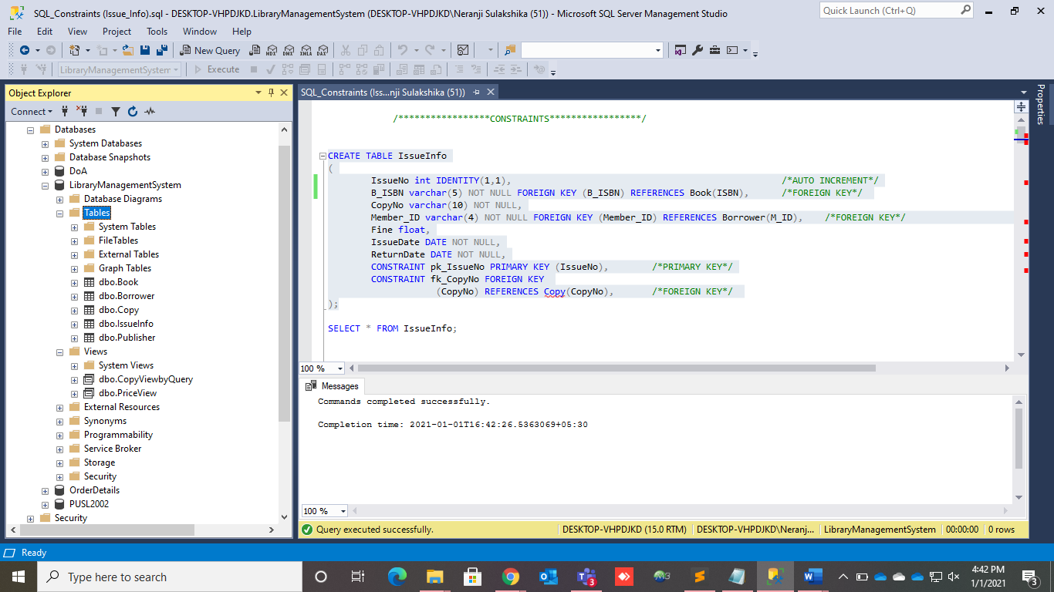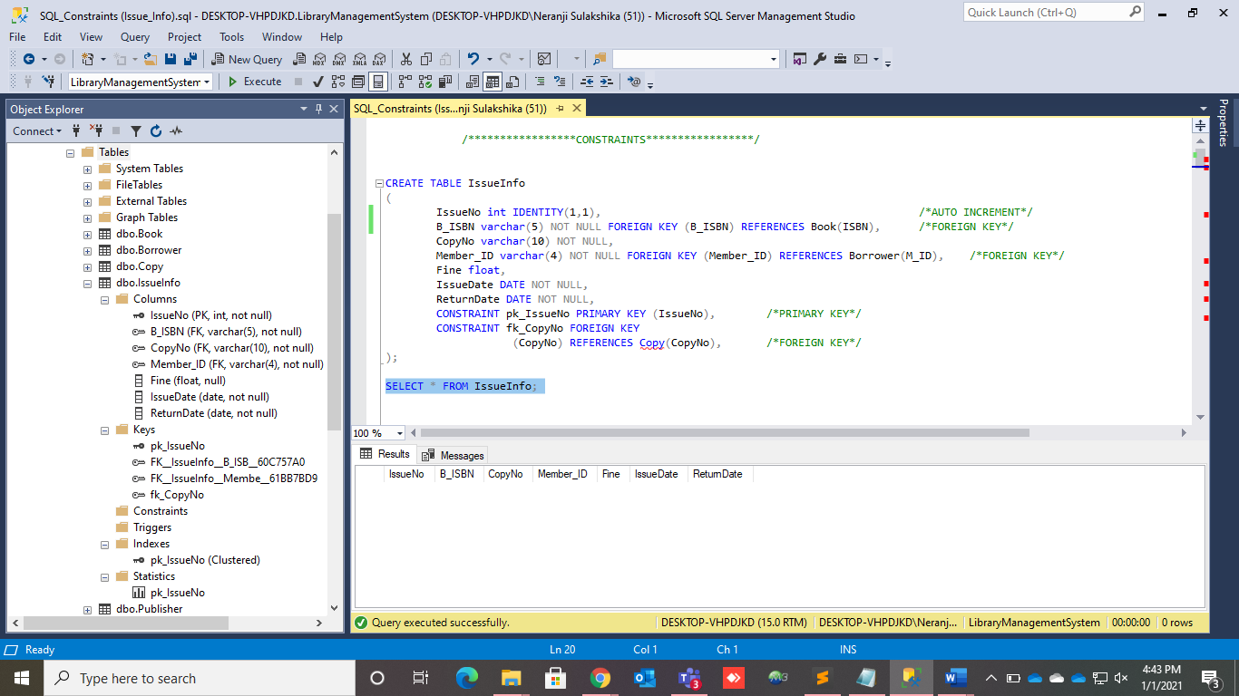

## STAFF TABLE

**Create table Staff**

Creating a database named Staff to start off creating tables and inserting data,



After creating database Staff and USE statement, created a table called StaffTable to insert details of all staff members considering StaffID as a primary key.



Only email is set to null field, as some if the staff members are not posses an email address. StaffID is set to be increment by 1 as a effective way to insert the data easily and avoid the integrity.

Email and both First Name and Last Name are considered as unique, in case to identify easily with. Also JoinedDate also added to show date that joined.



After creating table StaffTable, another table called AuthSysTable is also created within Staffid, Username and Passwords as an attributes.



Only staff members who are admin, their credentials are inserted into this table as well with their own staff id. Added a foreign key constraint to Staff ID

**Create Table New Staff Members**

After inserting data, I created another table for new members to identify the members who abled to joined quickly by using the statements,



## PUBLISHER TABLE

In order to create the publisher table, first of all the database must be created. So, the database would be Library

1. **Creation of database**



1. **Creation of the table with constraints**



After creating and executing the publisher table the following result of table occurs.



1. **LIBRARY TABLE**



The above are the sql statements that were used to create this table which includes a primary key (libcode) and a unique key (LibNumber). Further the libcode is the unique ID given to each library, the LibNumber is a unique key since there cannot be two or more libraries at the same place. Other columns like LibraryType is to know if the library is a main or branch, BranchName stores the name of the library. Where as city stores the city of the library and libNumber stores the building number of the library, these two could be known as the BranchAddress however a column like that isn’t created since we cannot put two values in one column. Apartfromthat the last column (copynumber) stores the number of copies received for each library.

# DB DIAGRAMS

# SAMPLE RECORDS

1. **BOOK TABLE**
2. **BORROWER TABLE**

**SAMPLE RECORDS OF BORROWER**



* These are the sample data which has been inserted into the table 20 records in which only 15 have been inserted.
* Execution results



## COPY TABLE

### Insert sample data

 

 

### Table of ‘Copy’ sample data in C#.

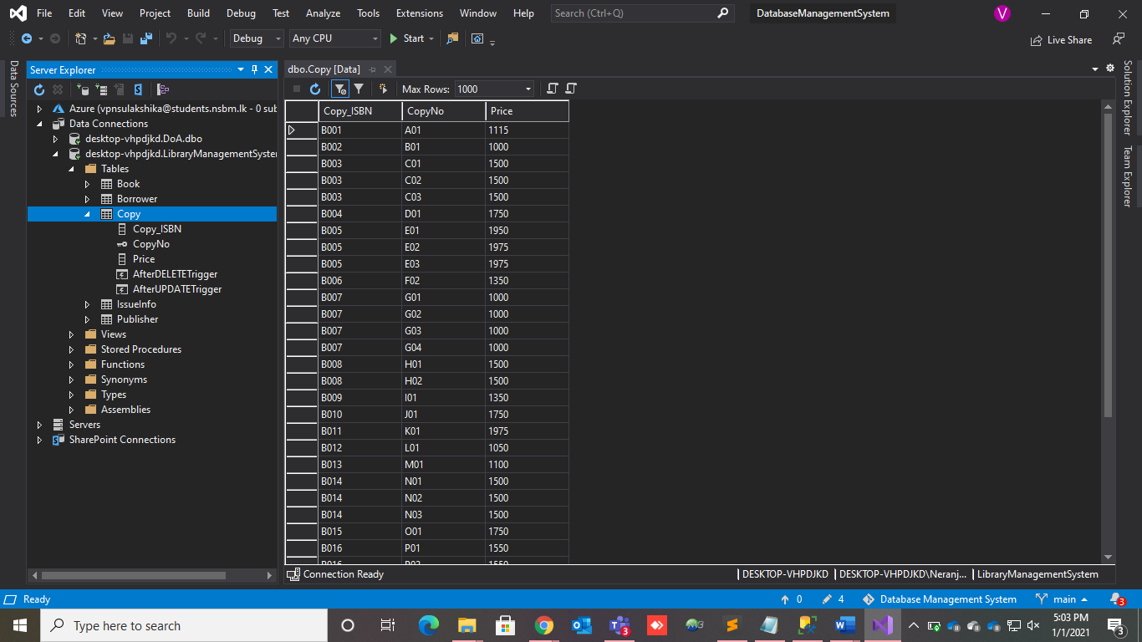 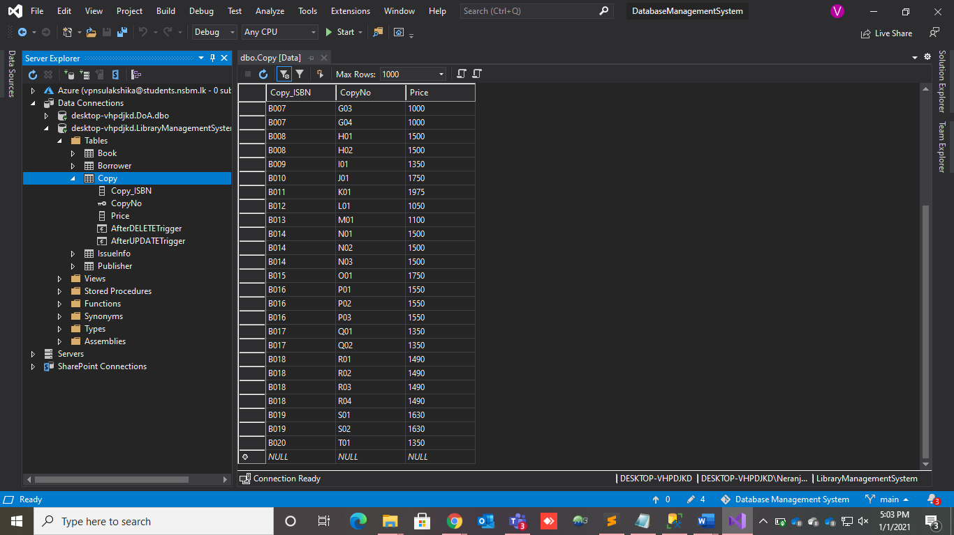

## ISSUE-INFO TABLE

### Insert sample data

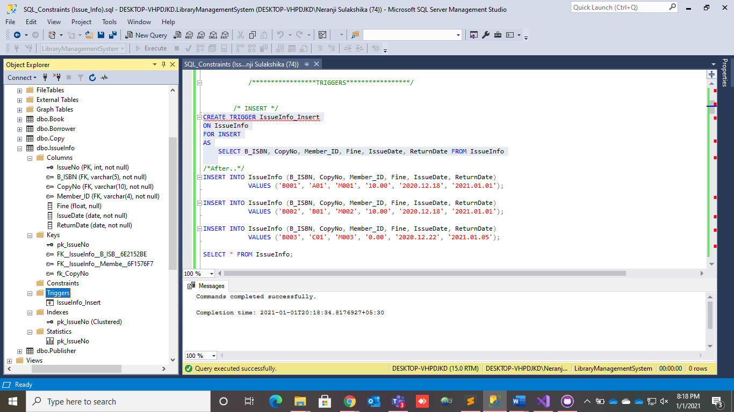

* This data inserted using SQL Server.

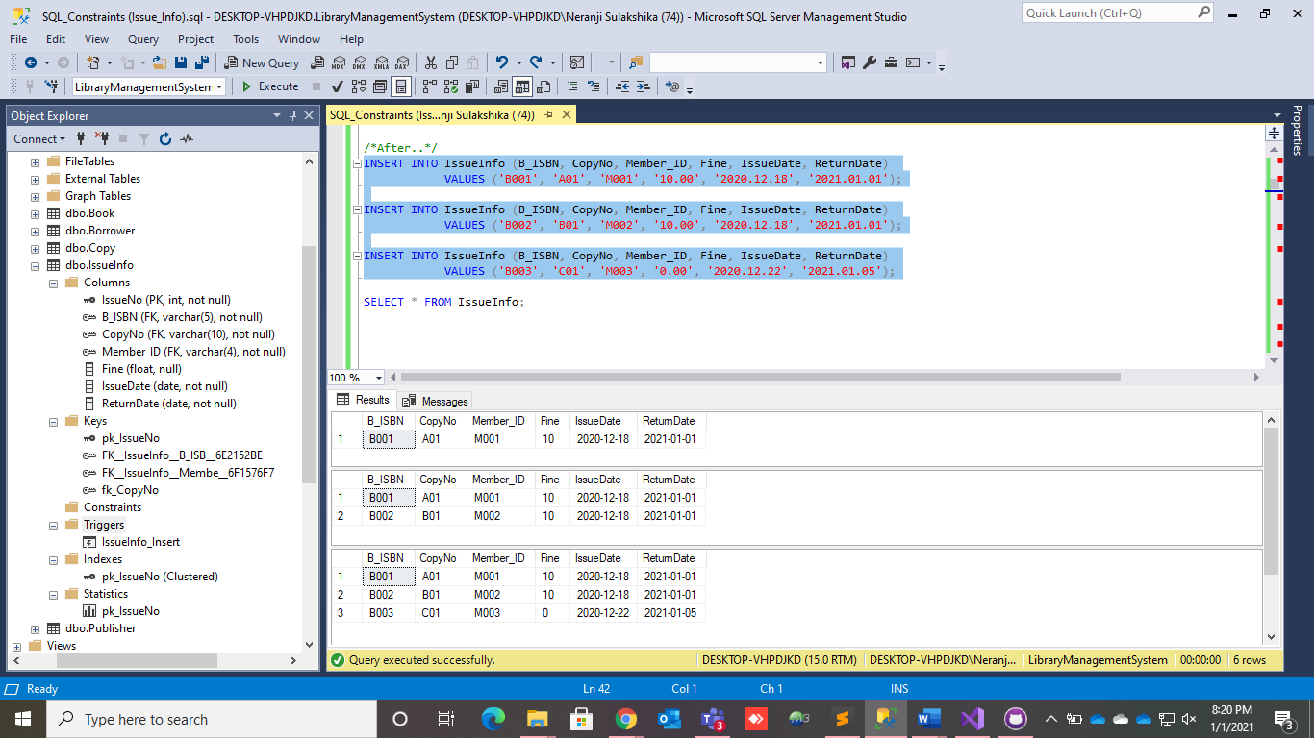

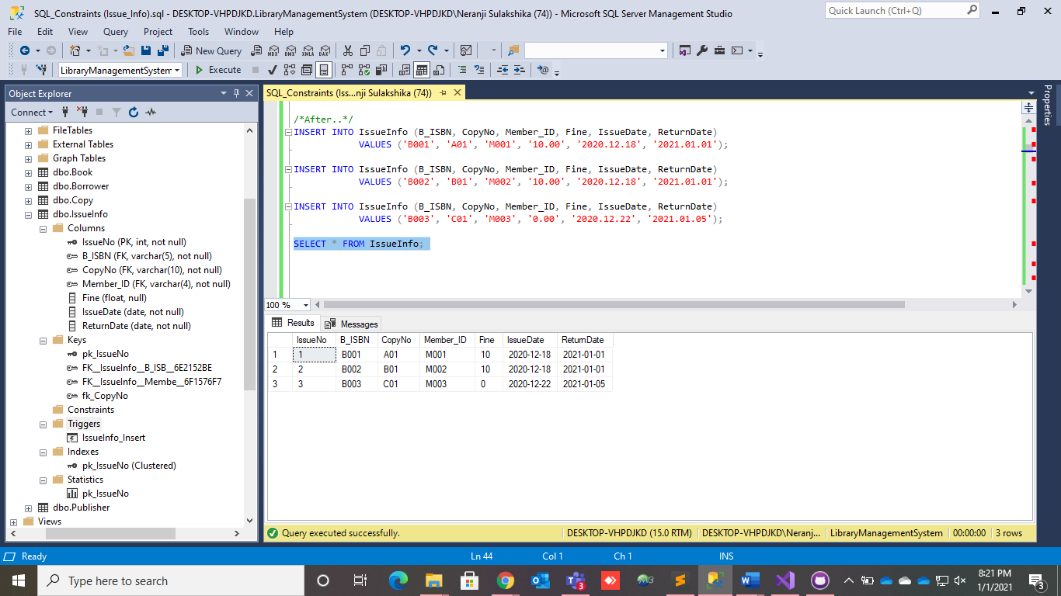

### Table of ‘IssueInfo’ sample data in C#.

* These other details inserted using C# interface.

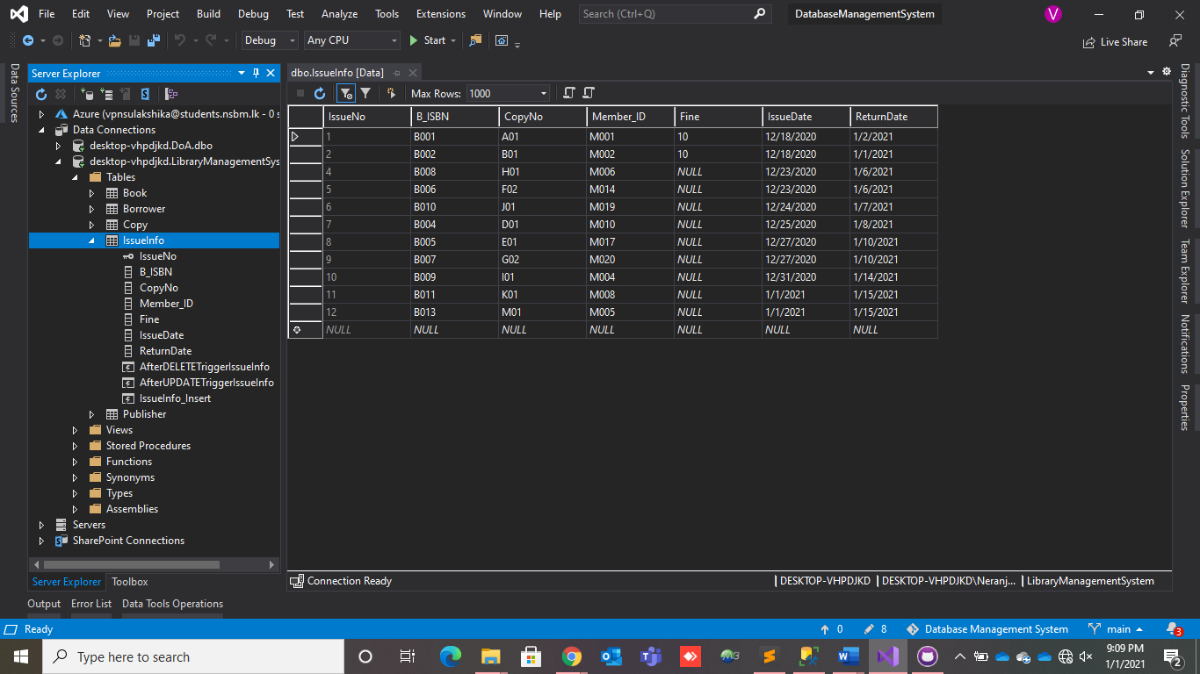

## STAFF TABLE

**Insert table staff**

Started inserting data(s) into the Staff Table,



After inserted data into the table, this is result,



## PUBLISHER TABLE

After creating the publisher table, we need to insert data into the publisher table.



After executing the values, below are the results of the entered values to the database.



# 3. SECTION 03

# TRIGGERS

## BOOK TABLE

## BORROWER TABLE

**TRIGGERS FOR BORROWER**

INSERT TRIGGER



* This trigger is created to trigger an event of which when a new member is being entered into the database the borrower table will be shown with the new entry along with another table showing that this person with the related M_ID has been entered into the database.
* Executed result



DELETE TRIGGER

* This trigger is created to trigger an event of which when a member is being deleted from the database the borrower table will be shown along with another table showing that this person with the related M_ID has been removed from the database. As shown below:
* Executed Result



UPDATE TRIGGER



* This trigger is created to trigger an event of which when a member’s details is being updated from the database the borrower table will be shown with the newly updated entry along with another table showing that this person with the related M_ID’s details had been updated from the database. As shown below:
* Executed result



## COPY TABLE

### After Update Trigger

* Create and execute the ‘AfterUpdateTrigger’.

 

 

### After Delete Trigger

* Create and execute the ‘AfterUpdateTrigger’.



 

## ISSUE-INFO TABLE

### Insert trigger

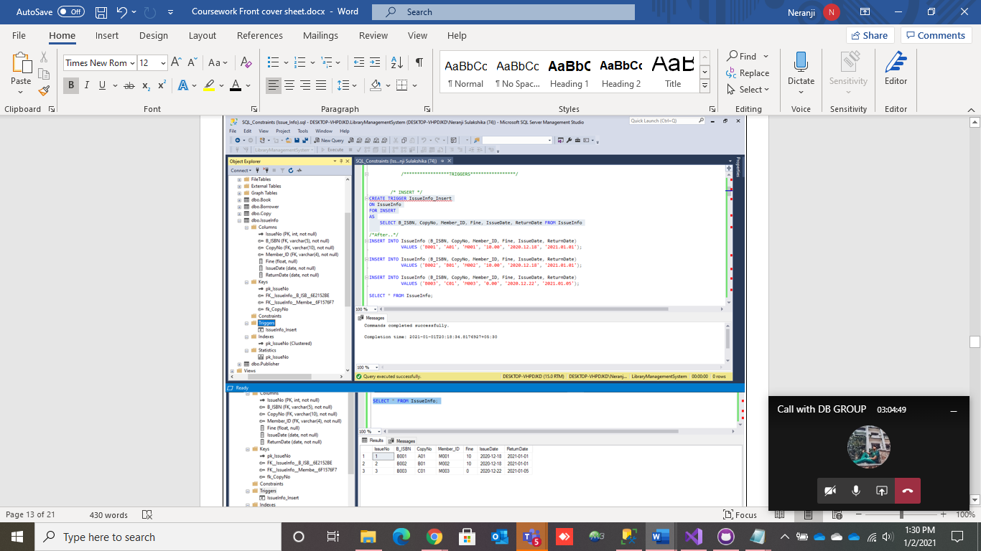

### Delete trigger

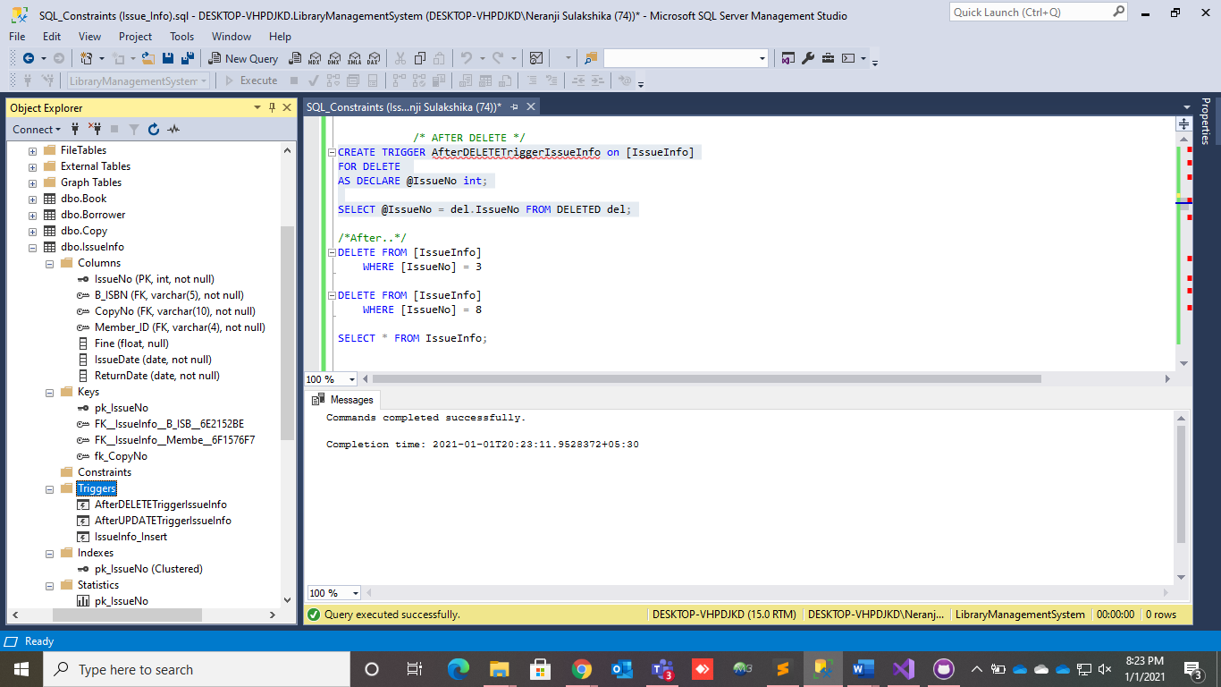

* Creating and executing the delete trigger.

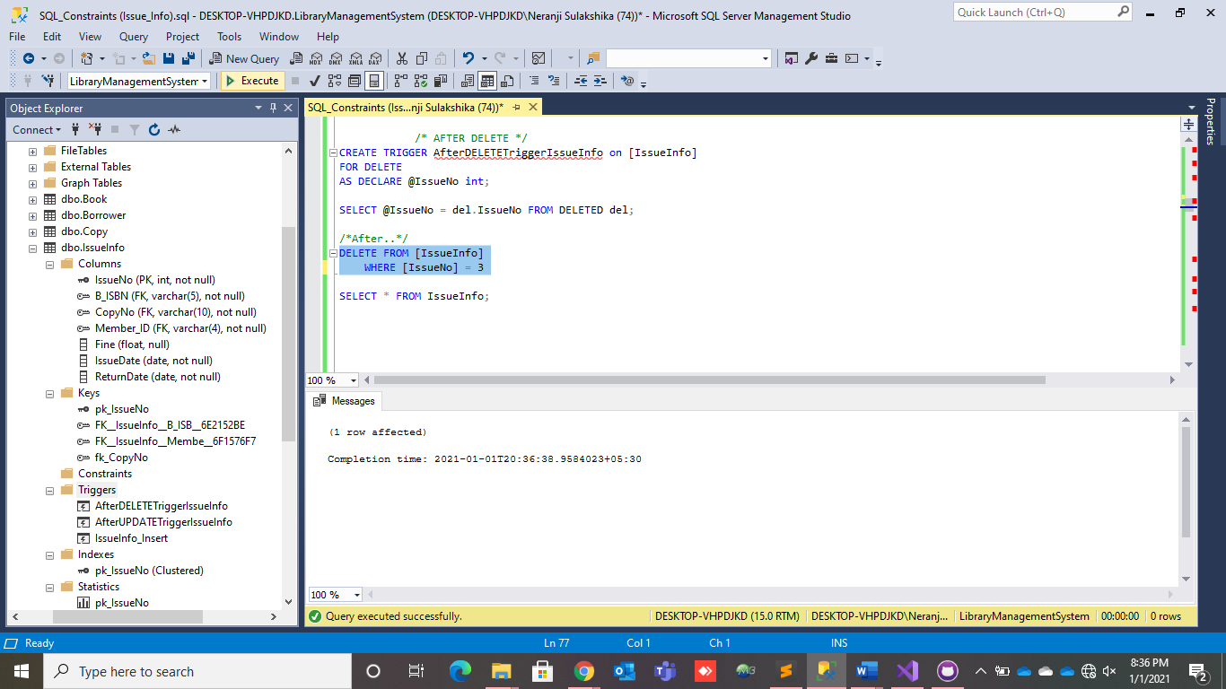 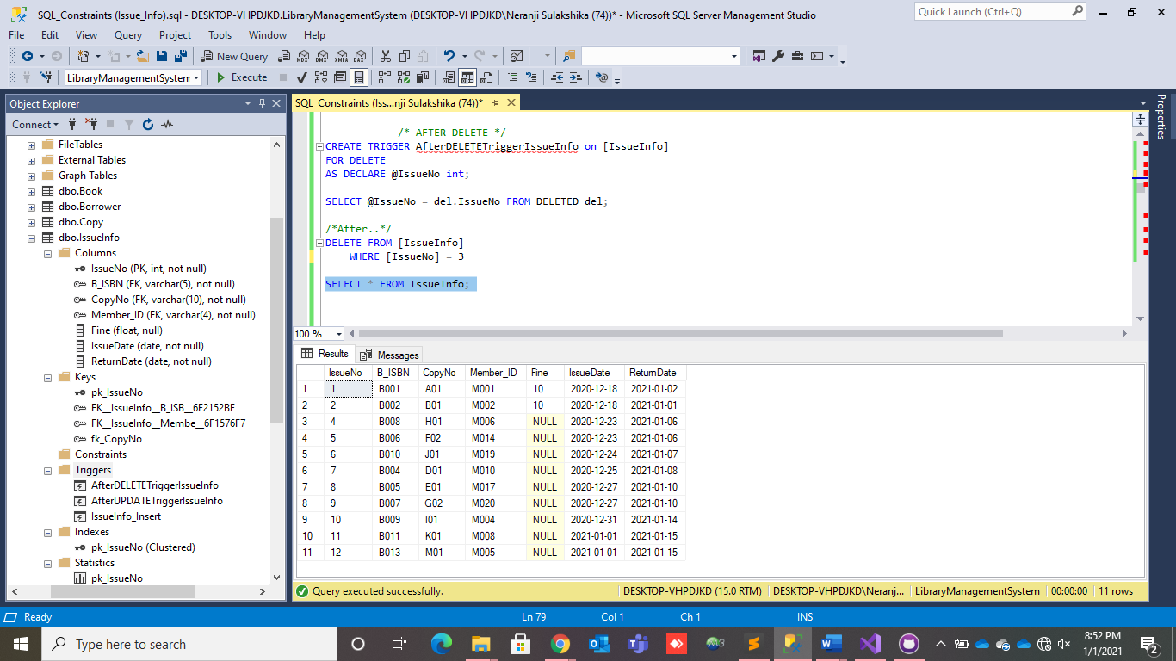

### Update trigger.

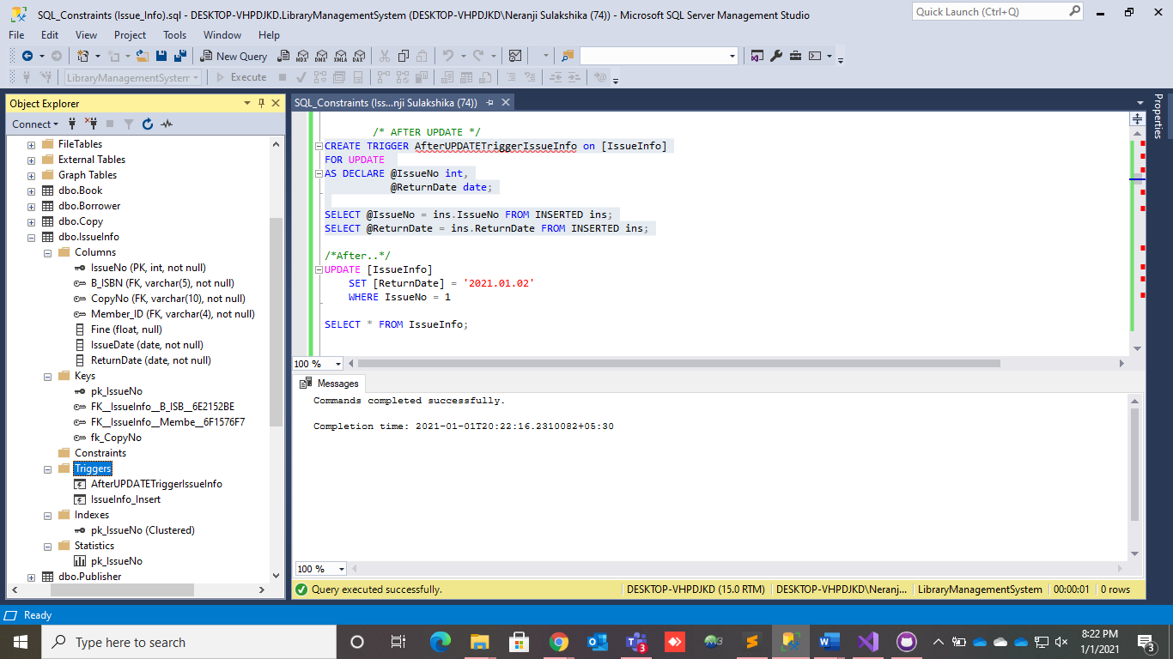

* Creating and executing the update trigger.

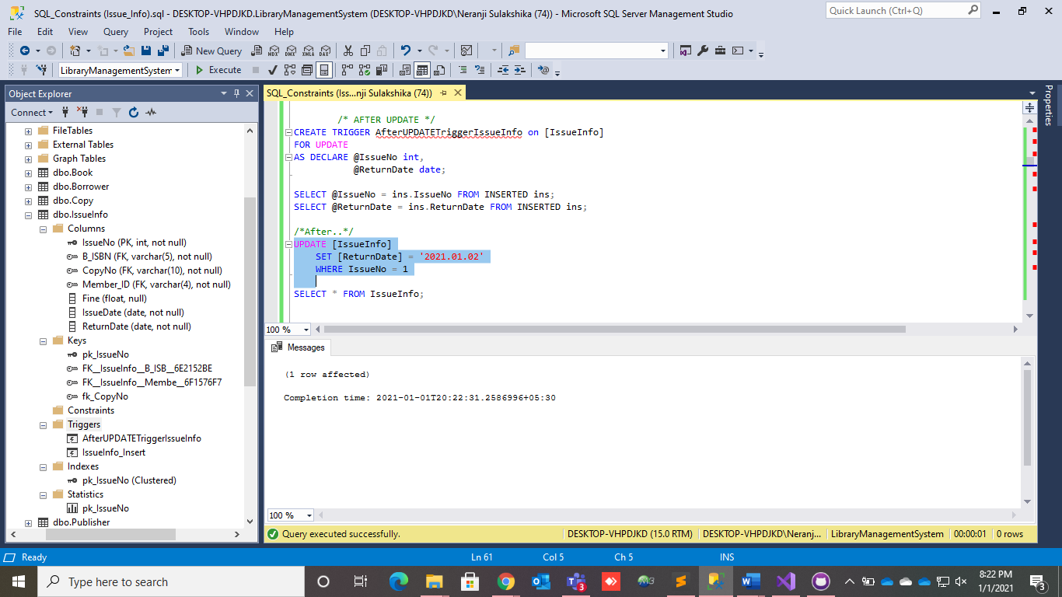 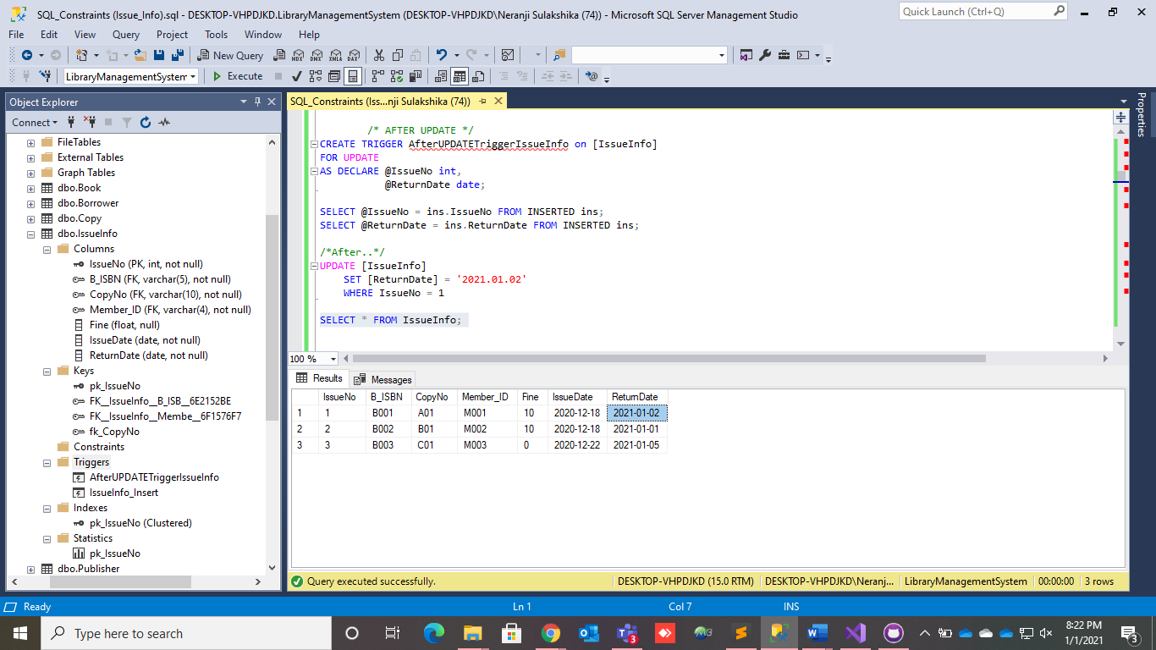

## STAFF TABLE

**After Insert Trigger**

I created a trigger to insert the joined date with using GETDATE function as this will help to find who are the new members with their primary key, StaffID.



To find members who joined recently, I can use that execute by following command,



**After Update Trigger**



With that when every single update event like this,



**After Delete Trigger**



When delete the staff id = 14 automatically the table will shown up in execution window like this,



## PUBLISHER TABLE

* **Creation of a trigger**



The above shows how to create a trigger.

* **Data insertion and the result after executing the trigger.**
* Here there is a default value coming of Colombo from Pub_City. This arise from the constraint using when creating the publisher table by using DEFAULT constraint. The last two rows shows the DFAULT Constraint of Column Pub_City.



* **Updating data using a trigger.**

The below is a result of the trigger used to update an already existing value in the table.



* **Deletion of an existing trigger**



* **Trigger to get the current date**



* I have used getdate() function to get the date automatically using the trigger. So when entering publisher details in to the table if the published date is not inserted to the table, by using date_update trigger the current date will be added to the published date column automatically.

# DATABASE VIEWS

## BOOK TABLE

## BORROWER TABLE

**DATABASE VEIWS FOR BORROWER**

VEIW TO GET MEMBER LOCATION DETAILS



* This view is created in-order to get all members location details which includes his/her Membership ID, District and the City.
* Execution result



VEIW TO FIND OUT THE MEMBERS WHO BORROWED BOOKS



* This view is created to find out which borrowers has borrowed books from the issue info table by doing this we get the borrowers member id first name and the ISBN of the book he/she borrowed.
* The Execution result is given below:



## COPY TABLE

### Create View

* Create and execute the ‘CopyViewQuery’.

 

### Create View

* Create and execute the ‘PriceView’.

 

## ISSUE-INFO TABLE

### Create View

* Create and execute the ‘CreateIssueInfoMemberView’.

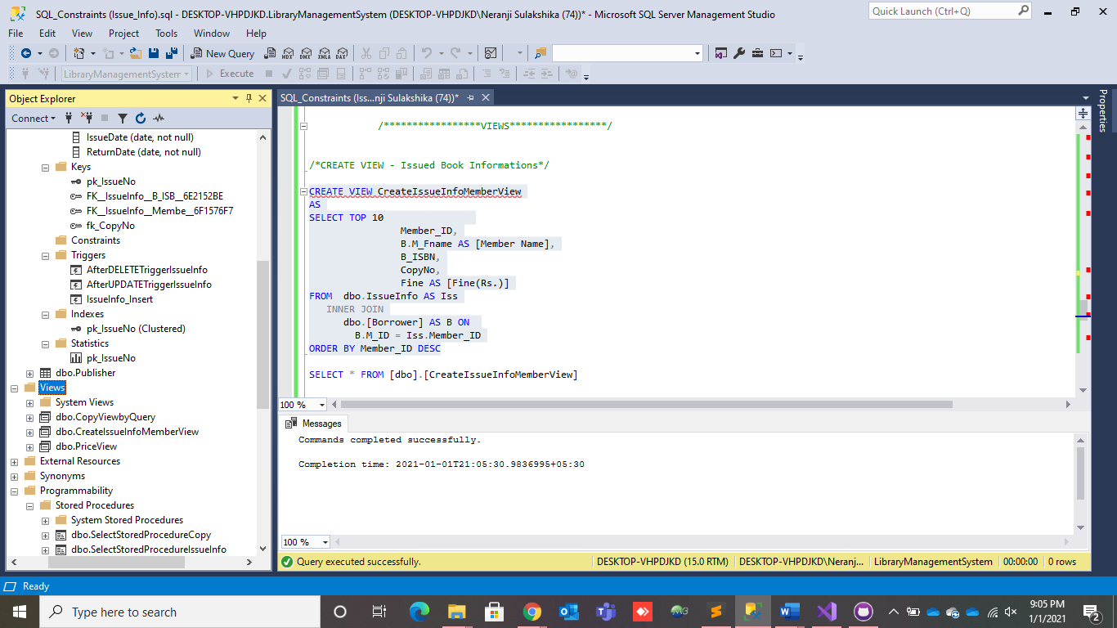 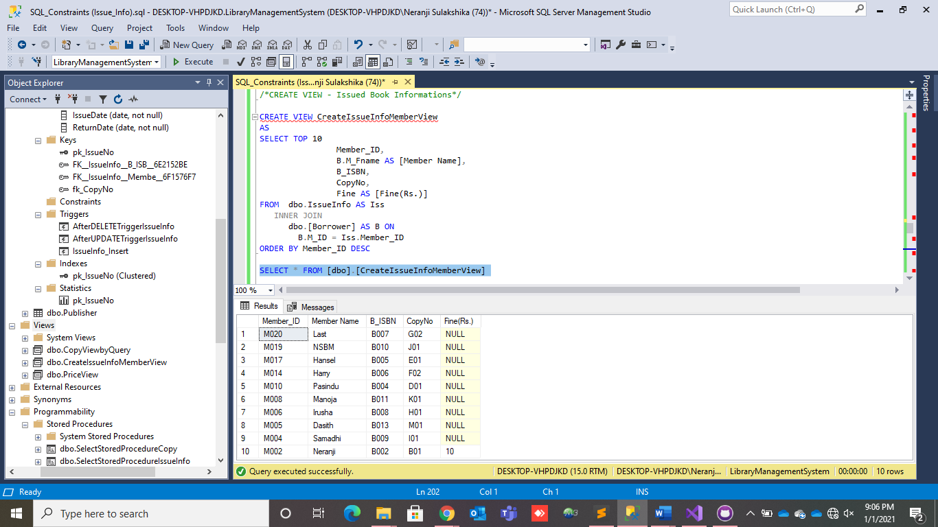

### Create View

* Create and execute the ‘CreateFineView’.

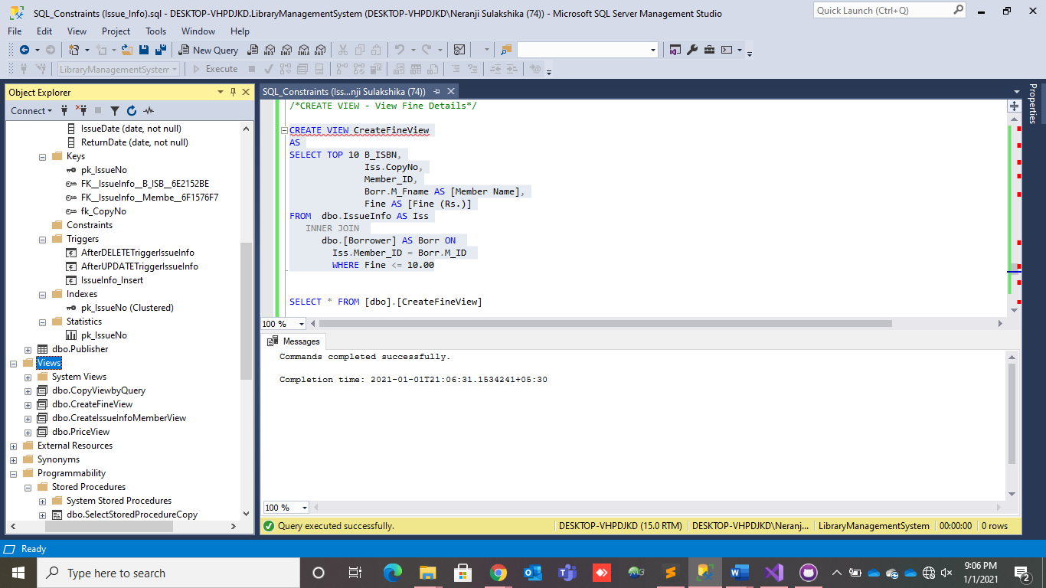 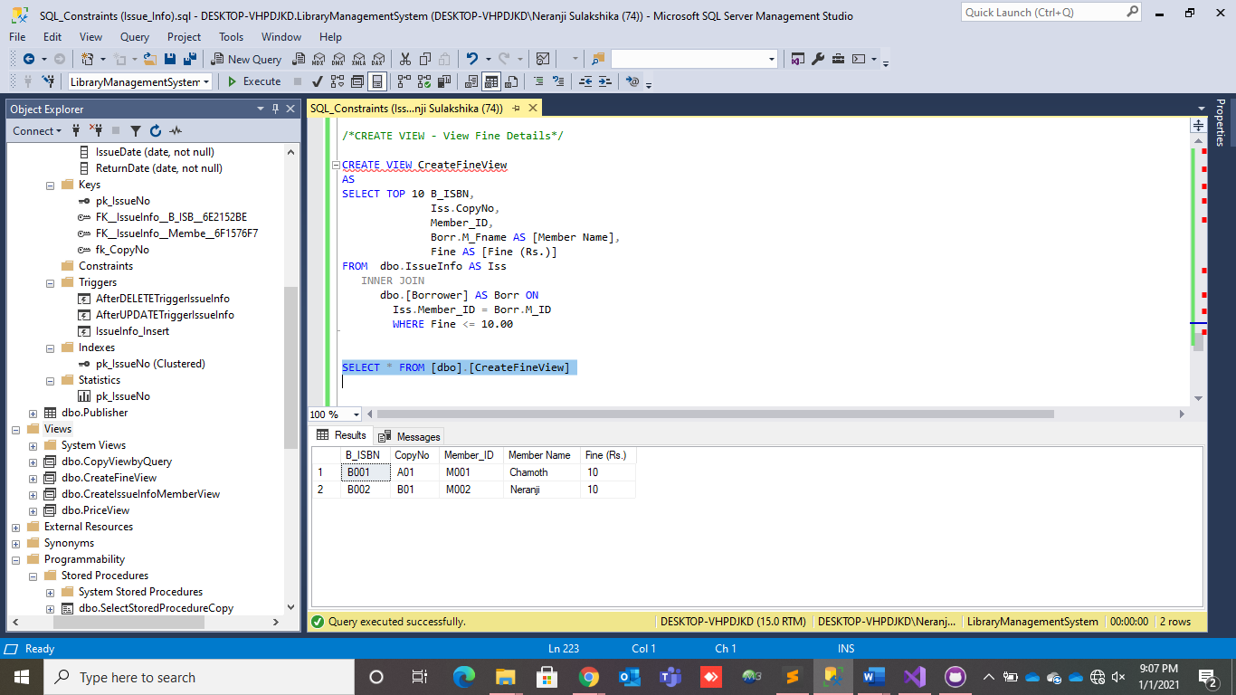

## STAFF TABLE

1. **Create View for ADMIN_INFO without credentials**

To find the all information of specified conditions like StaffRole, I used view functions that able to execute so quickly.



Now this is for find administrators’ info without credentials that provided as in AuthSysTable, with this view named Admin_INFO you can seek all info about admins except credentials by using,



And the result is,



1. **Create View for OLD_Members**

A view to seek the info about old staff members . In this case old members as staff members who joined the library since more than a year.

And the result is showing only old staff members that satisfying above condition.



## PUBLISHER TABLE

1. **Creating a view**

* The below is an example of creation and execution of the view.



* This view is created to find the publisher by using the Pub_ID. So if the user type the Pub_ID, publisher will be seen in the results

.

1. **Creation of a view to find the publisher by country**



* This is another view created to find the publishers by using the country. Here after executing the country all the publishers in the relevant country will be published.

1. **Creating a view using multiple tables**



* This view is created by using the publisher and the book tables.
* I have used joins here to create them.
* This basically shows the Pub_ID, Pub_Name, ISBN, B_Name, B_Author, and the Pub_Date.
* This can be used to find which author published which book rather than comparing Published_BookID in the publisher table and ISBN in the boom table.

# USER DEFINED FUNCTIONS

## BOOK TABLE

## BORROWER TABLE

**USER DEFINED FUNCTIONS**

FUNCTION TO FIND OUT THE COUNT OF MEMBERS IN A DISRTICT



* By using this function, we can find out the count of members who comes from a particular district a value needs to be passed either its COLOMBO, GALLE OR JAFFNA. Then the count will be displayed accordingly.
* Execution are as follows



FUNCTION TO CHECK WETHER A PERSON HAS A CITY OR NOT



* By using this function we can find out the wether a given members city is given or NULL this can be simply done by passing the members Membership ID into the statement and if its Null its YES and if its NOT NULL then NO.
* Execution are as follows.



## COPY TABLE

### Create SQL Scalar Functions.

* Create and execute the ‘average' function.

 

### Create SQL Scalar Functions.

* Create and execute the ‘LibraryCopy’ function.

 

## ISSUE-INFO TABLE

### Create SQL Scalar Functions.

* Create and execute the ‘SummationOfFine' function.

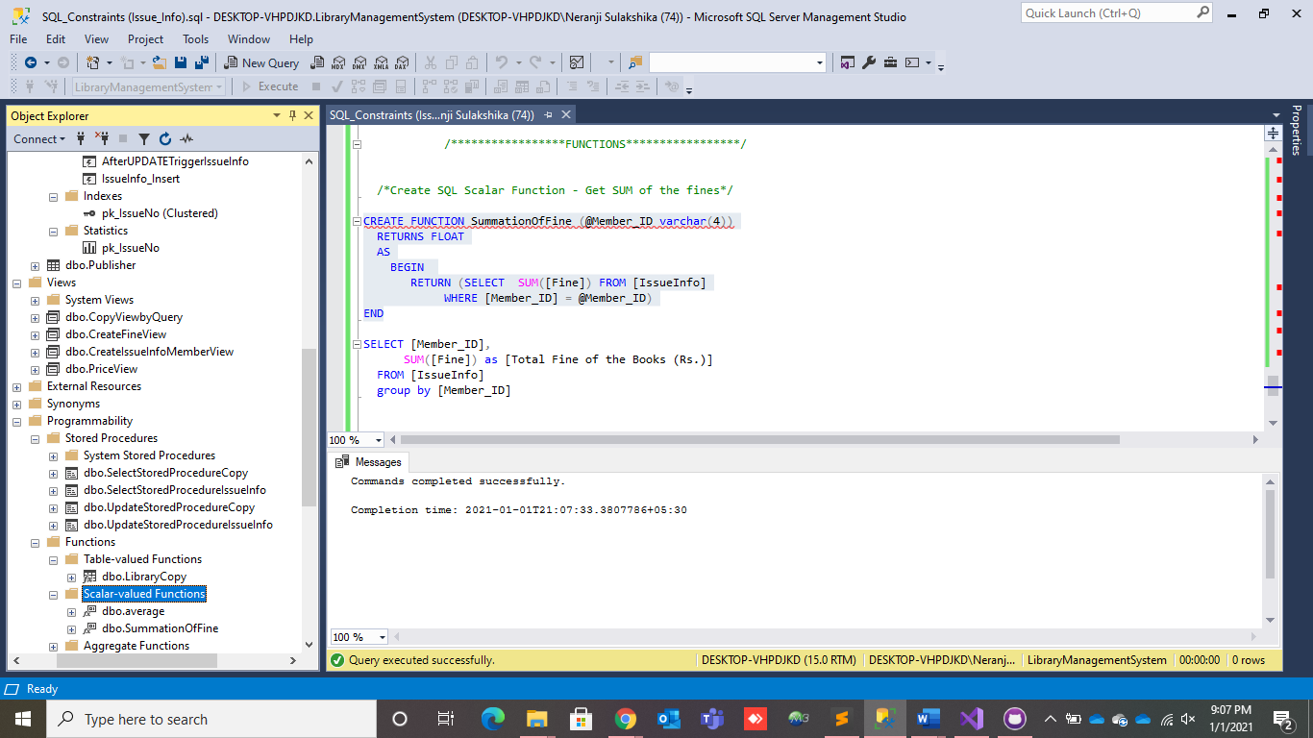 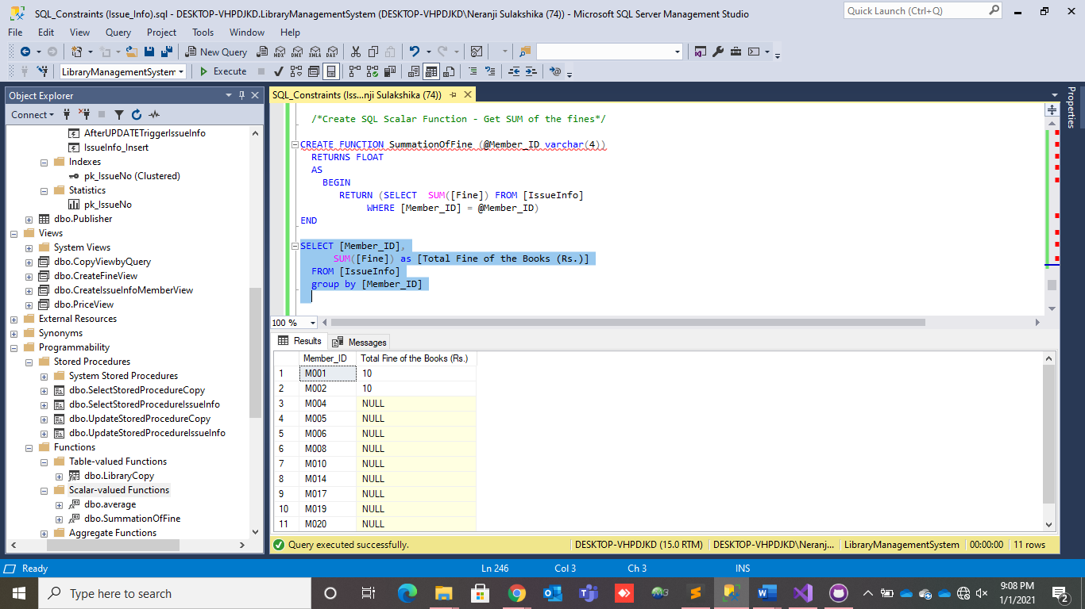

### Create SQL Scalar Functions.

* Create and execute the ‘CheckFine' function.

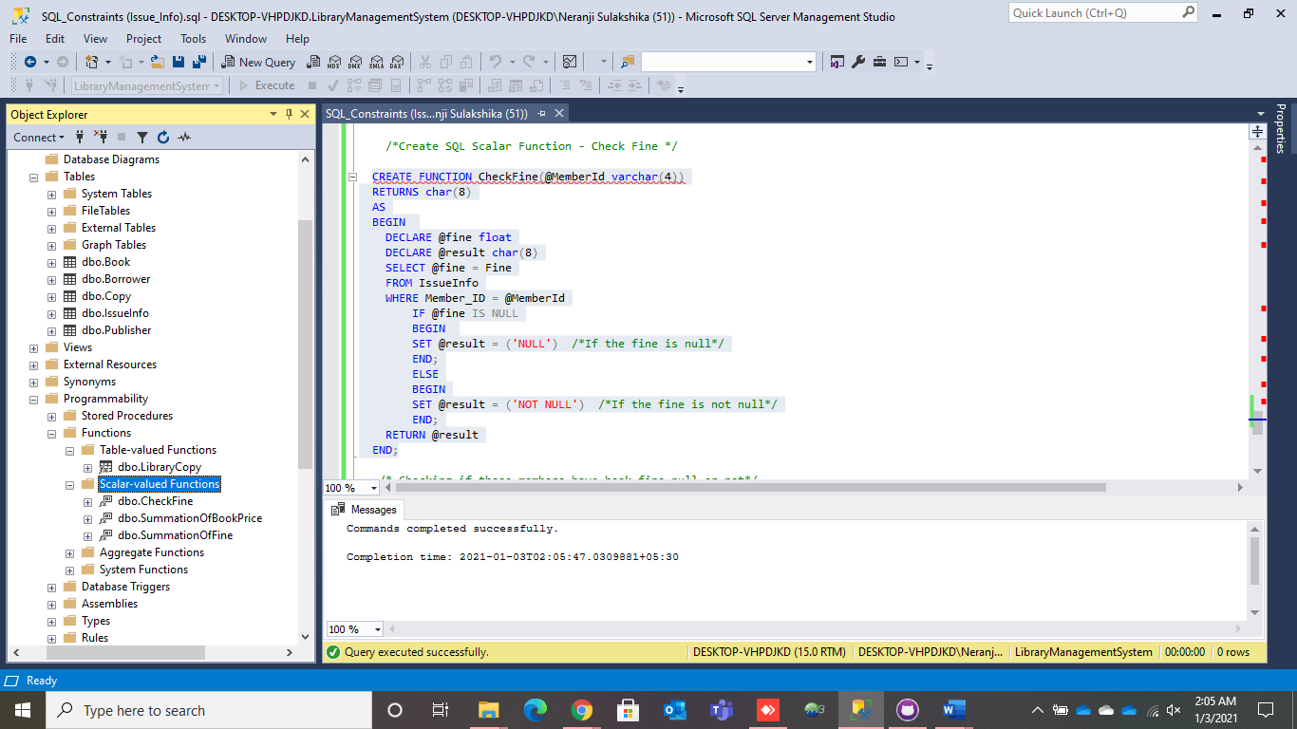

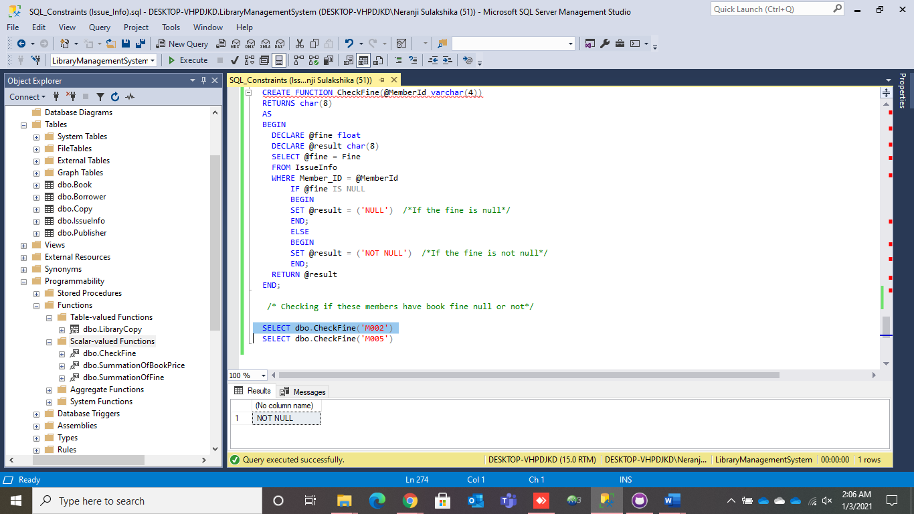 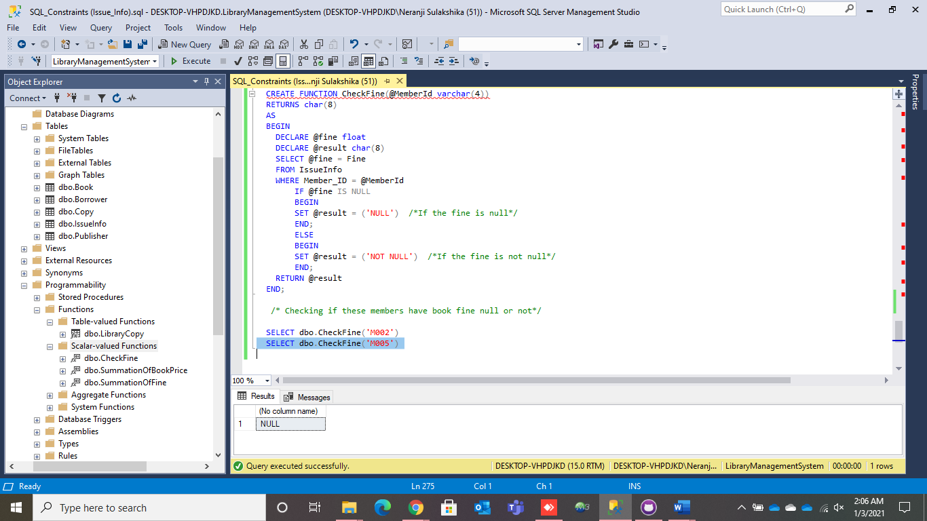

## STAFF TABLE

1. **Create a function for search information just by Staff ID**

Creating functions can make yourself easy to search information just hitting by a desired key like an example as Staff ID,



After creating this, a member can enter just by Staff ID to load any of details of specified person by using following statement.



So, the Staff ID is 5 as, we are about to find the full name by that desired staff id, and therefore the result like this,



1. **Create a function to search the joined date just by Staff ID**

Finally, I created another function to perform the execution of joined date of a staff members just entered within staff id,



And execution part can be done through this,



As to find the joined date of staff member who represent by staff id ‘7’ can be displayed like this,



## PUBLISHER TABLE

* **Creating a function**



* This is the result after creating and executing the function.
* This function is used to find the publisher name and the published country after entering the publisher id.
* This is an easy way to access the publisher details by using the publisher id.
* **Creating a function using the Pub_Country**



* The above is a scalar function.
* I have created this function to find the publishers who lives in United States.
* By using this function we can find the publishers who lives in US and their information.

# STORED PROCEDURES

## BOOK TABLE

## BORROWER TABLE

**STORED PROCEDURES**

PROCEDURE TO GET MEMBERSHIP INFORMATION DETAILS



* We can use this procedure to input a members ID and get his/her membership details as it showcase the members joined date and membership expiry date.
* Execution details are as follows:



PROCEDURE TO GET CONTACT INFORMATION OF A MEMBER



* We can use this procedure to find out a particular member contact information so when a membership ID is being passed the related member will be displayed along with the email address and telephone number of the borrower.



## COPY TABLE

### Select Stored Procedure.

* Create and execute the ‘SelectStoredProcedure’.

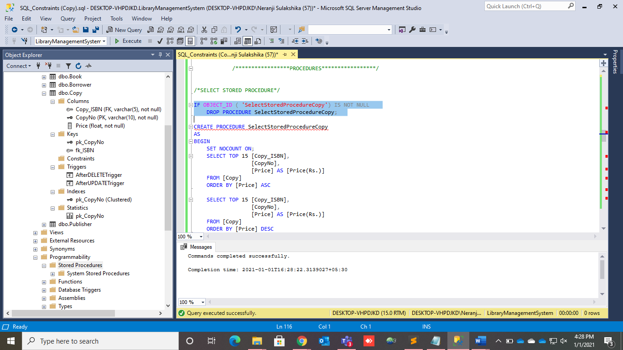

* Creating and executing the select stored procedure.

1. Execute the select stored procedure II. Execute the select stored procedure

order by Price with ASC order. order by Price with DESC order.

 

1. Execute the select stored procedure IV. Execute the select stored procedure order by Price with ASC order. order by Price with DESC order.

 

1. Execute the select stored procedure procedure order by Price with ASC order.



### Update Stored Procedure.

* Creating and executing the update stored procedure.

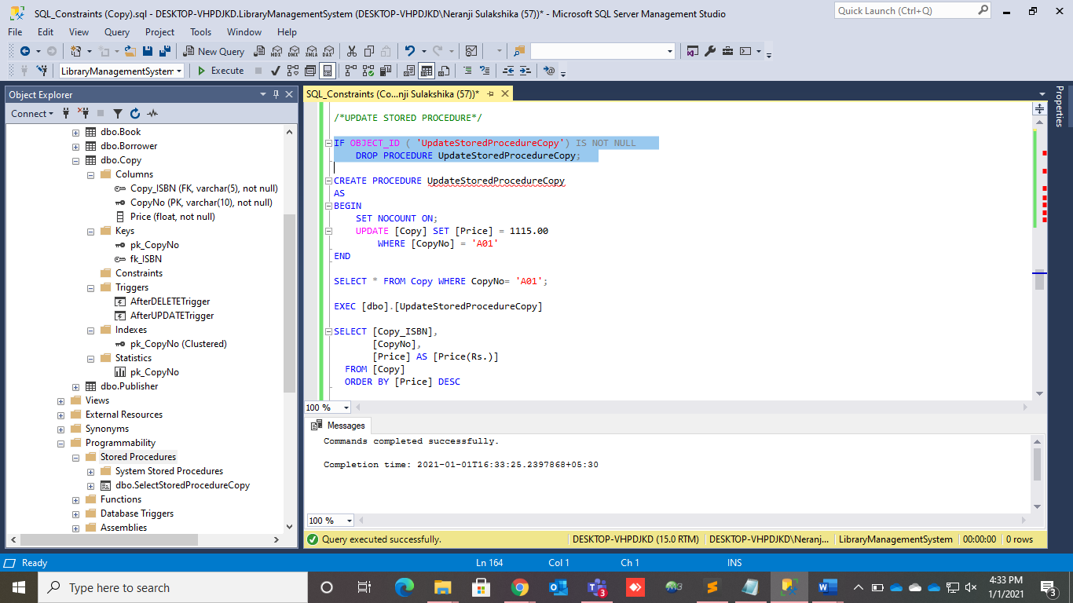 

1. Execute the select stored procedure procedure order by Price with DESC order.  

## ISSUE-INFO TABLE

### Select Stored Procedure.

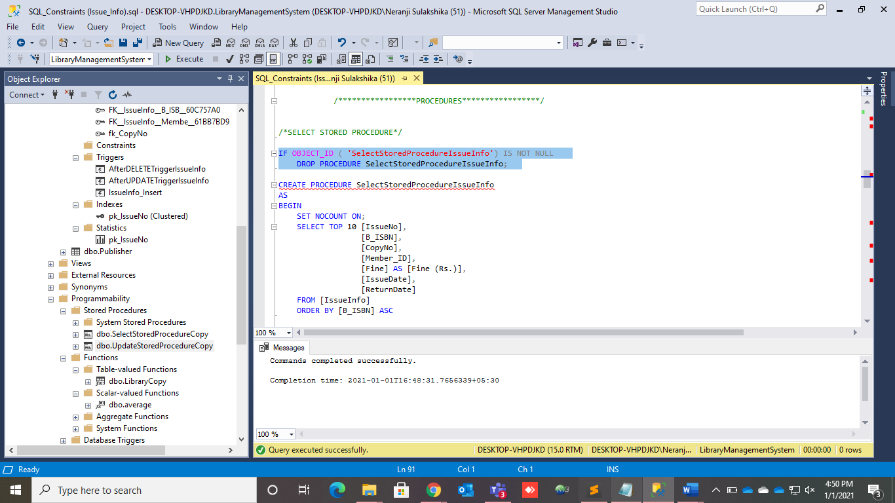

* Create the select stored procedure.

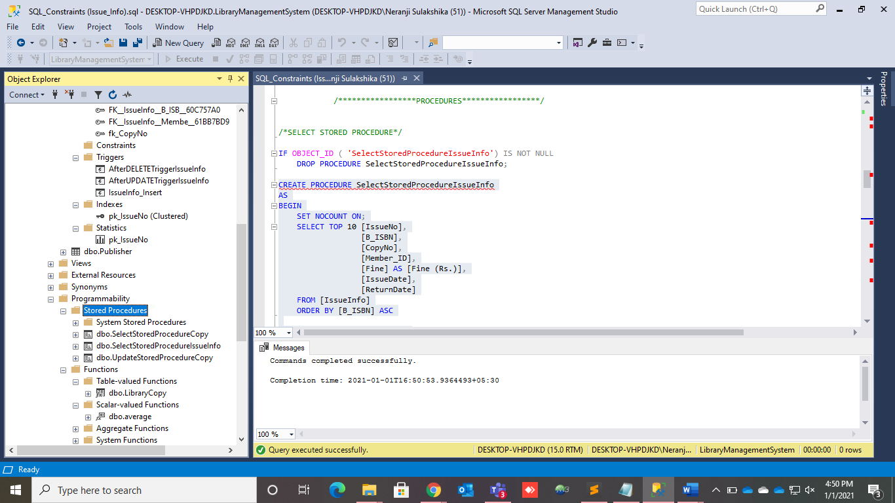

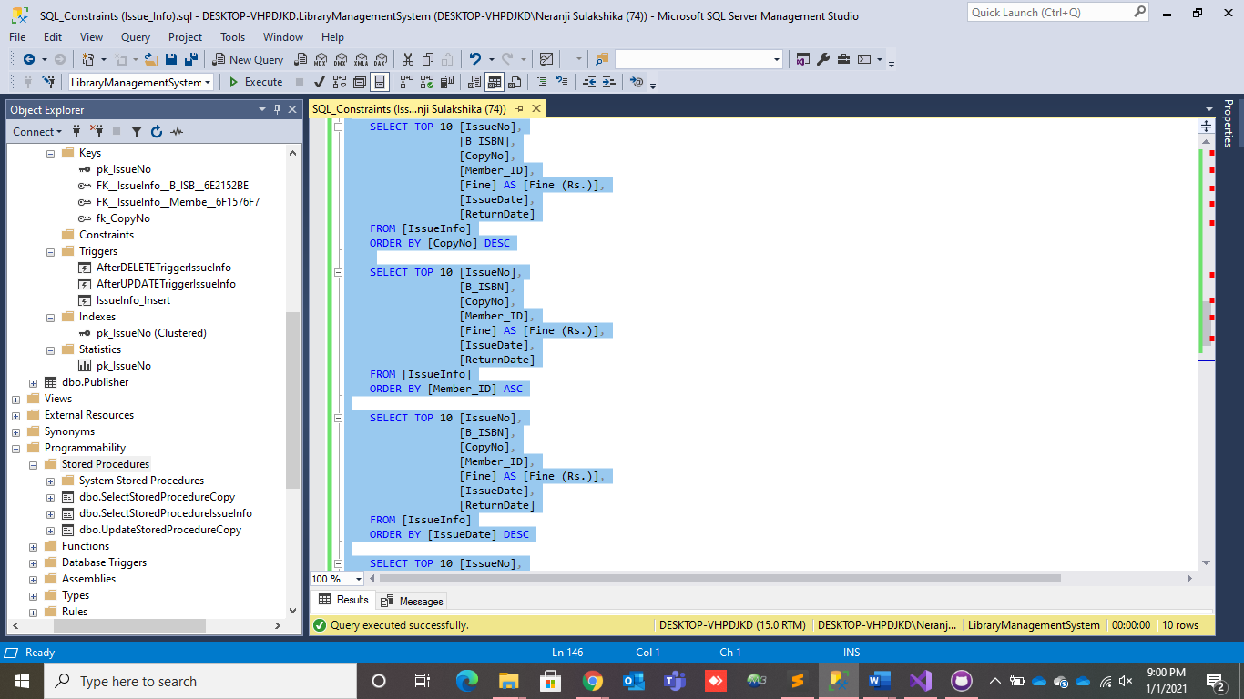 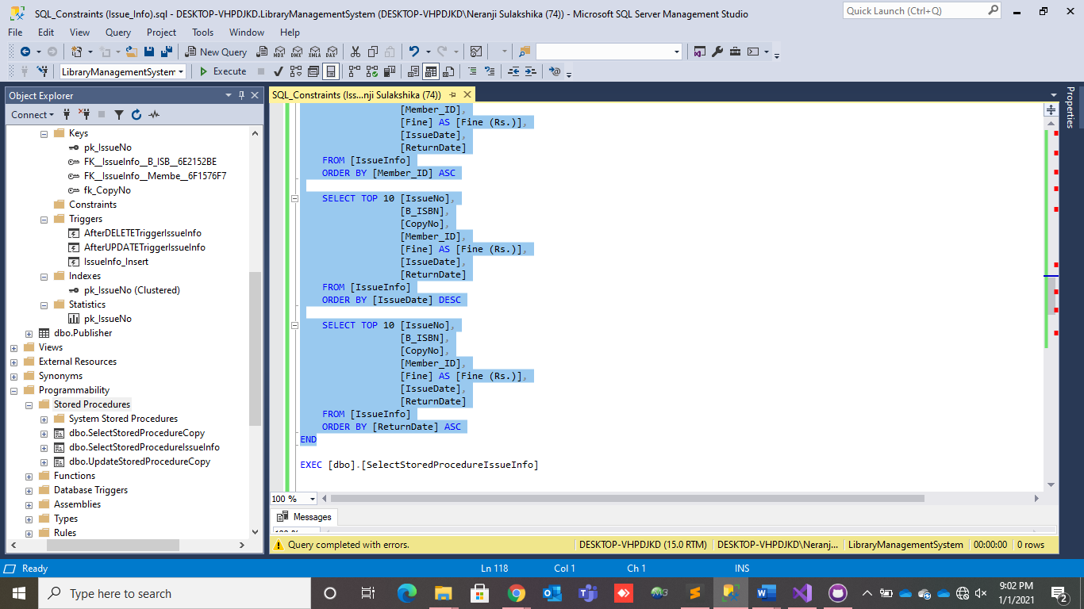

* Creating and executing the select stored procedure.

1. Execute the select stored procedure II. Execute the select stored procedure order by B_ISBN with ASC order. order by CopyNo with DESC order.

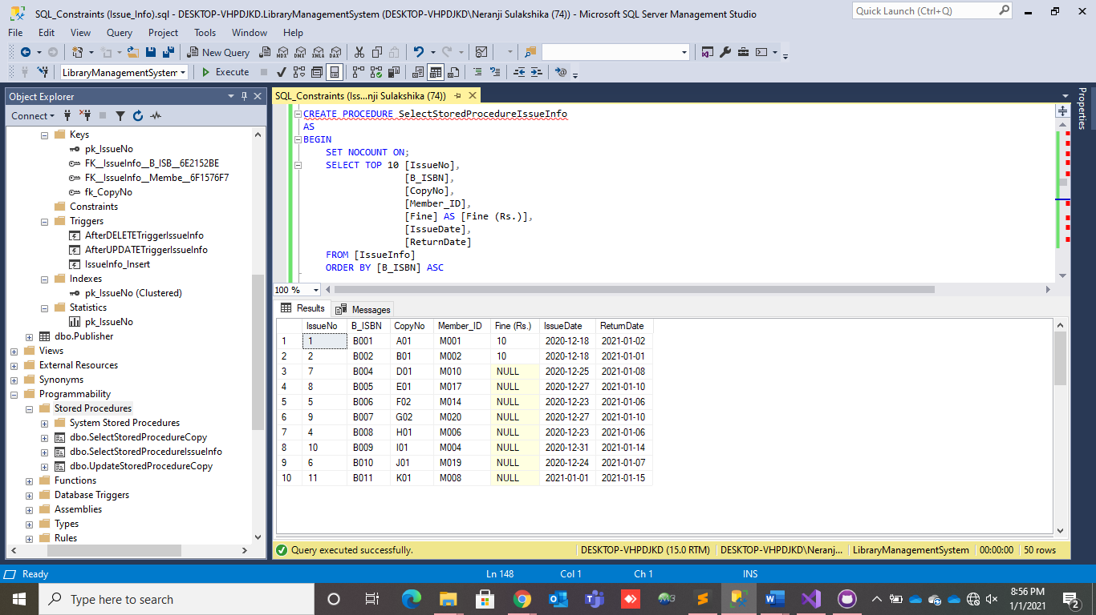 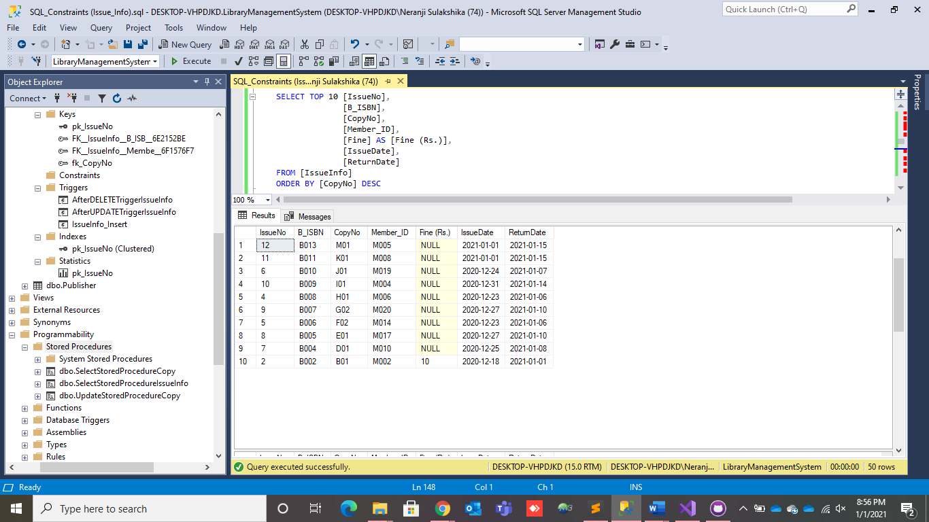

III. Execute the select stored procedure IV. Execute the select stored procedure order by Member_ID with ASC order. order by IssueDate with DESC order.

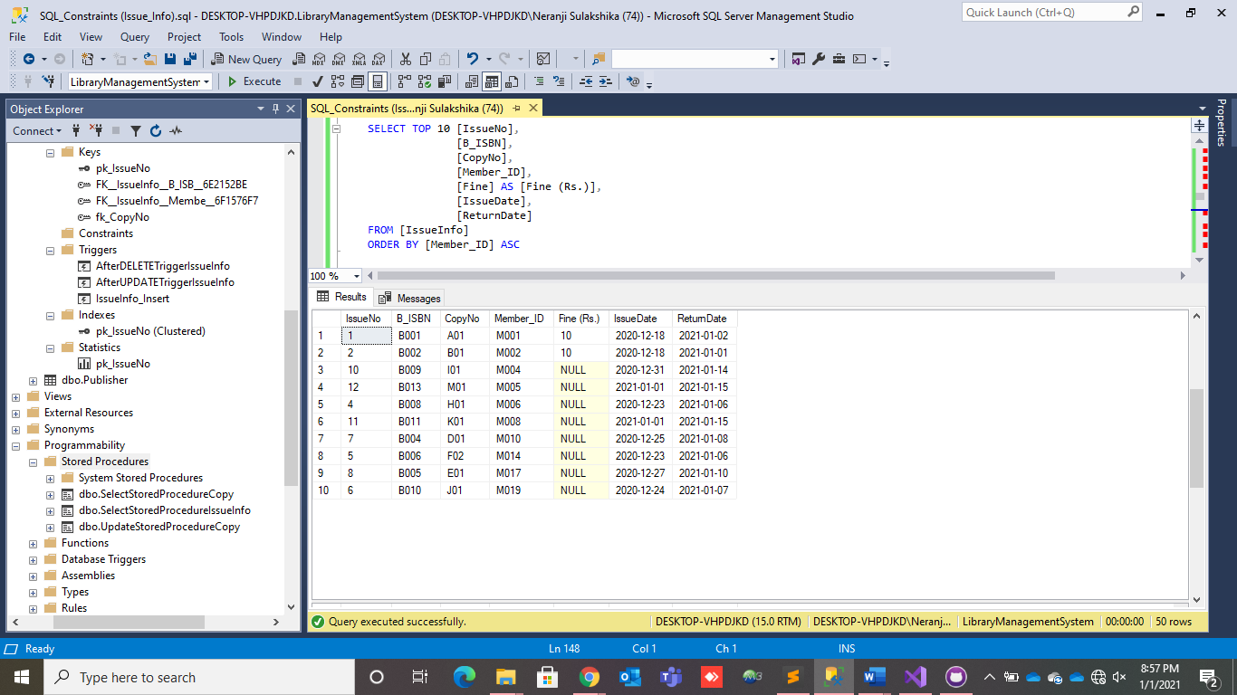 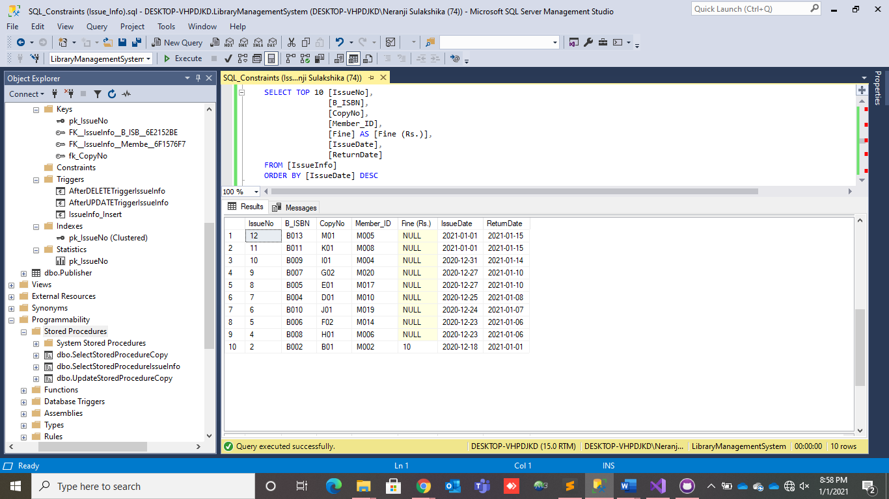

V. Execute the select stored procedure order by ReturnDate with ASC order.

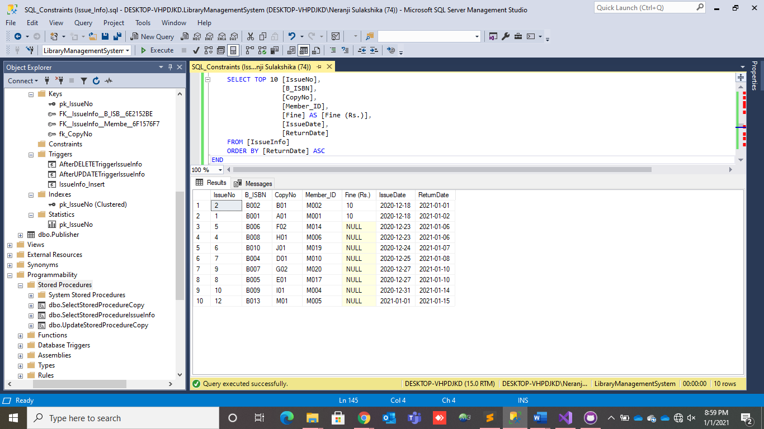

### Update Stored Procedure.

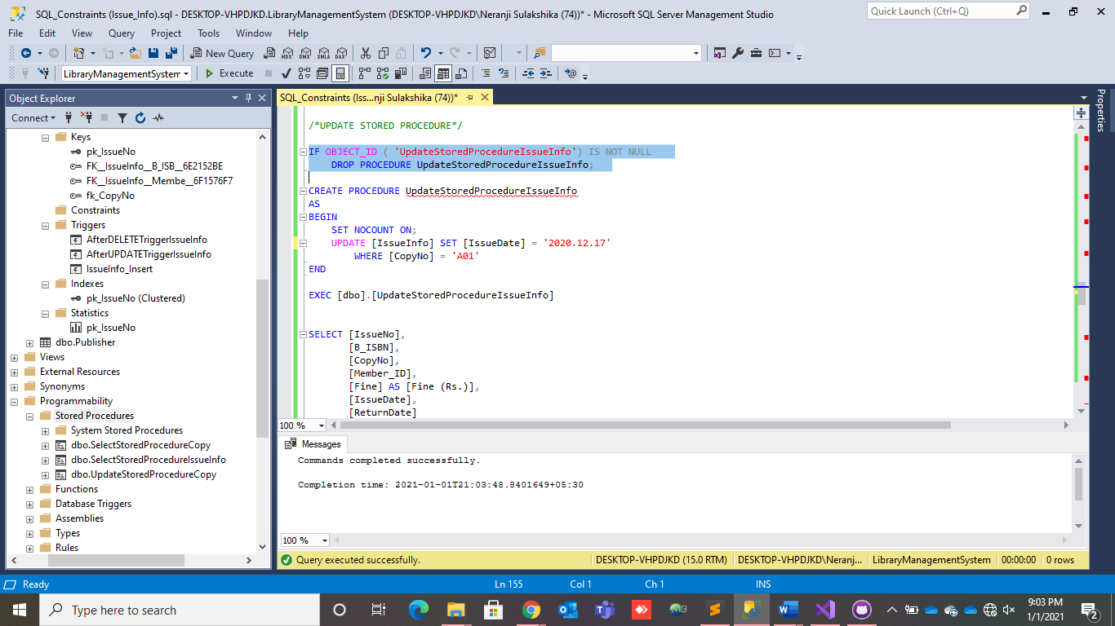

* Create and execute the update stored procedure.

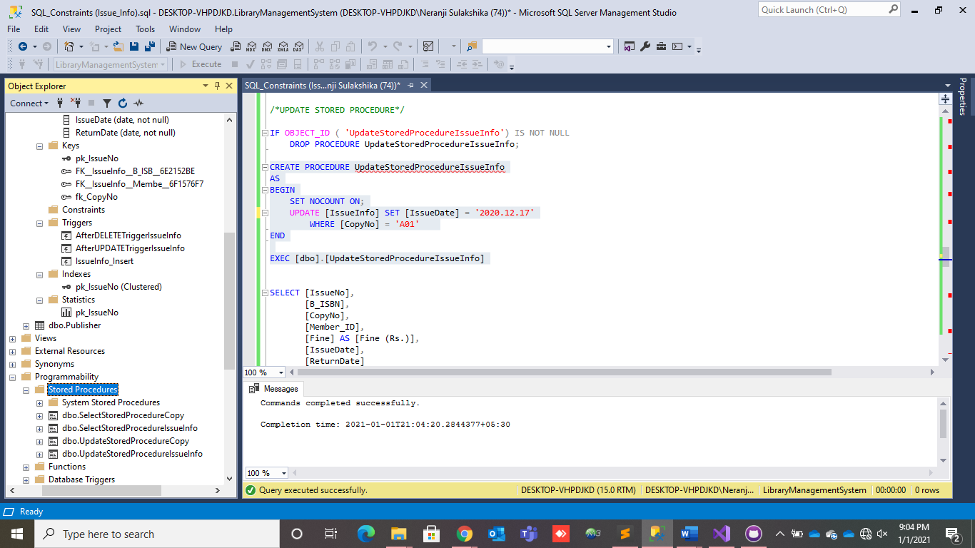 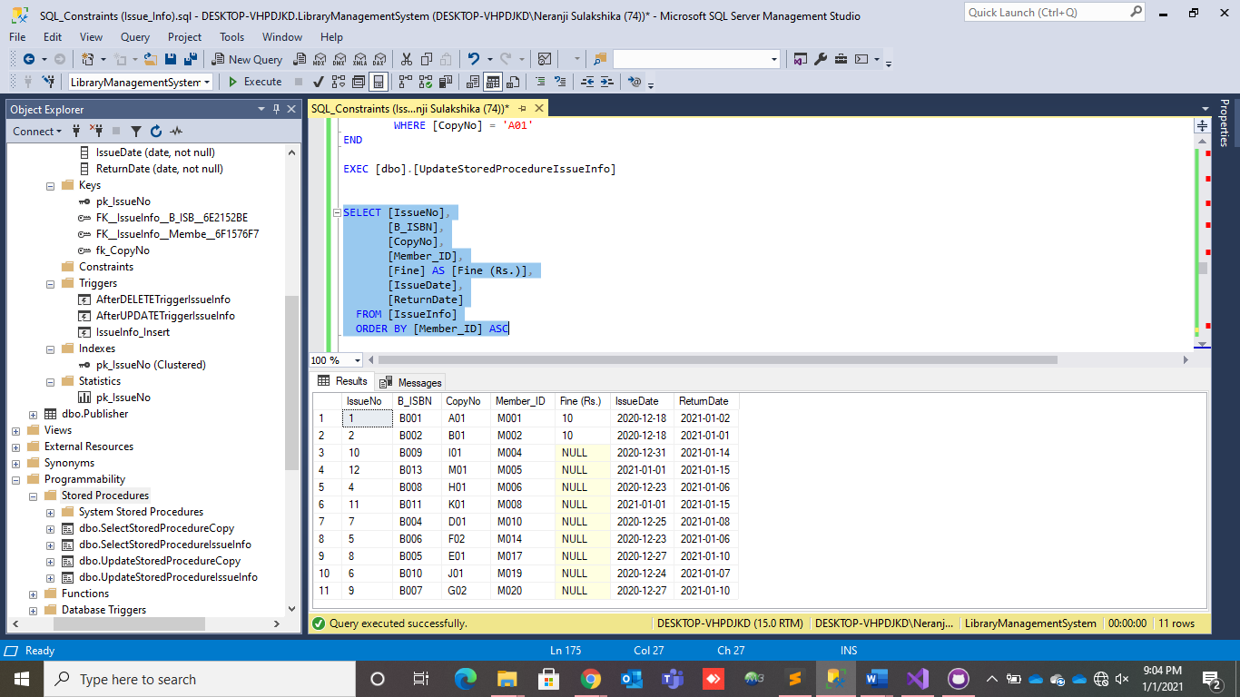

## STAFF TABLE

1. **Create a procedure list of book keepers.**

Now, I created another interesting feature that able to view whole information by any single attribute or multiple attributes. For example like this below, I expect to extract only details from book keepers in library,



With that to execute with following command,



And the result is,



1. **Create a procedure for admin info with credentials**

I used staff id here because it helps to view whole staff members’ info those who have credentials but this time with the credentials too. To this I used create procedure function as it joins both StaffTable and AuthSys table,



With this, result has to be executed by using following,



The result can be like this,



## PUBLISHER TABLE

1. **Procedure to find the publisher by ID**



* I have created a procedure to find the publisher. The above is the result after creating and executing the procedure.
* In here, by searching the Pub_ID we can get information about publisher of publisher name and the publisher contact.

1. **Function to find the number of publishers**



* This function is the result after creating and executing the function.
* By using this function we can find out how many publisher records are there in total.

# 4. SECTION 04

# CRITICAL EVALUVATION

# FUTURE IMPLEMENTATION

# LIBRARY MANAGEMENT SYSTEM – INTERFACES

## LOGIN INTERFACE

## BACKGROUND INTERFACE

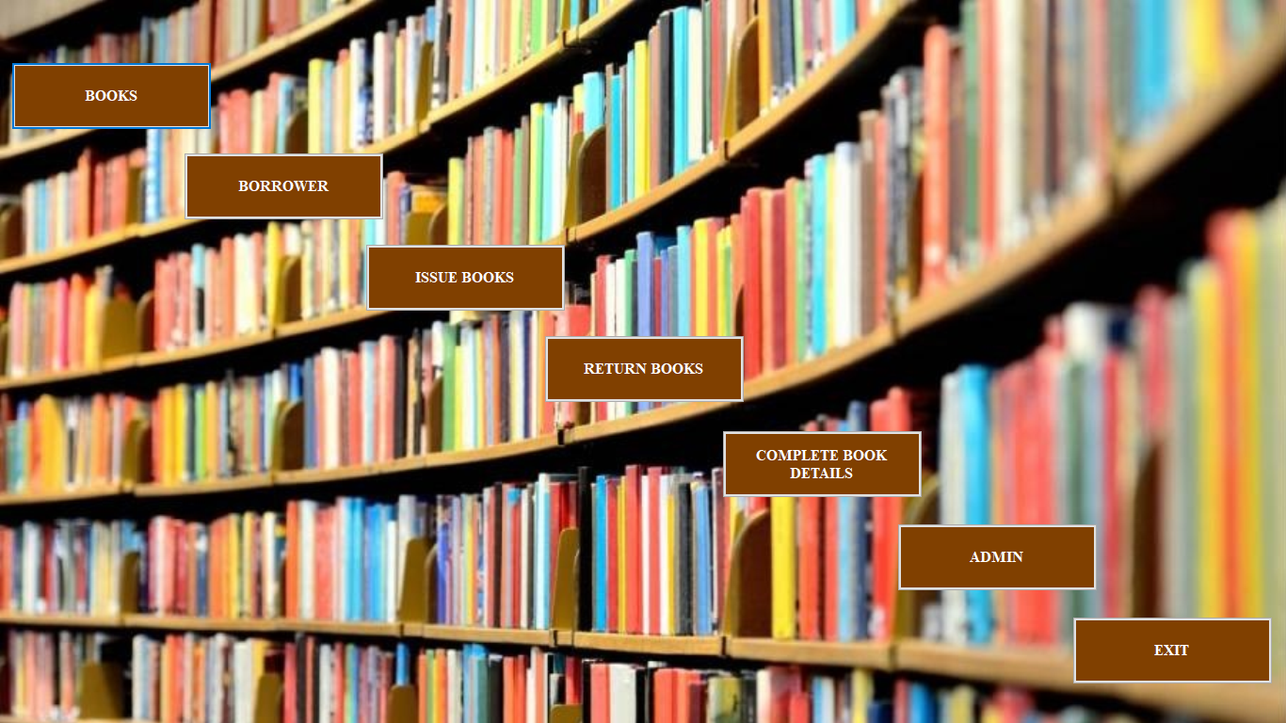

## BOOK INTERFACE

## BORROWER INTERFACE

## ISSUE-BOOK INTERFACE

### HOW IT WORKS?

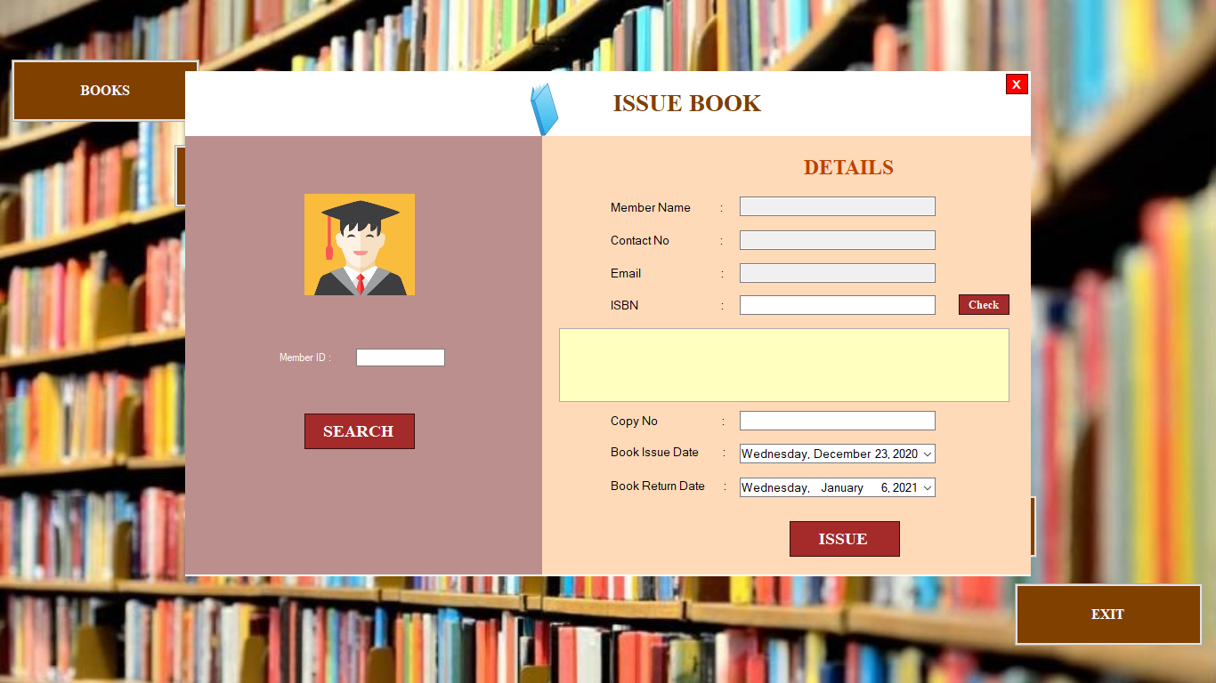

* **When the Member ID is entered and after clicked on the ‘Search Button’, this interface shows the Member name, Contact number, and email of the member.**

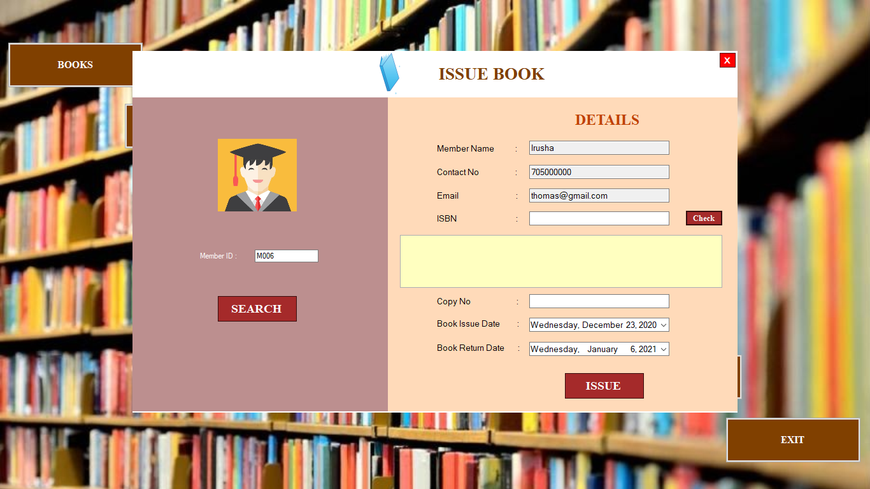

* **This is the coding part of the ‘Search Button’.**

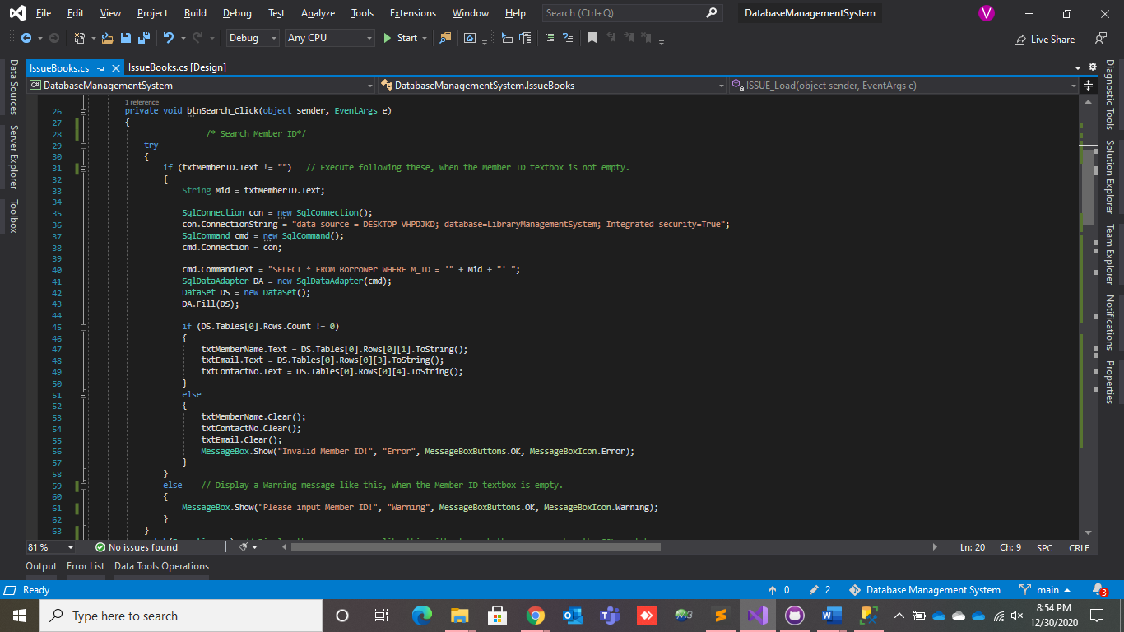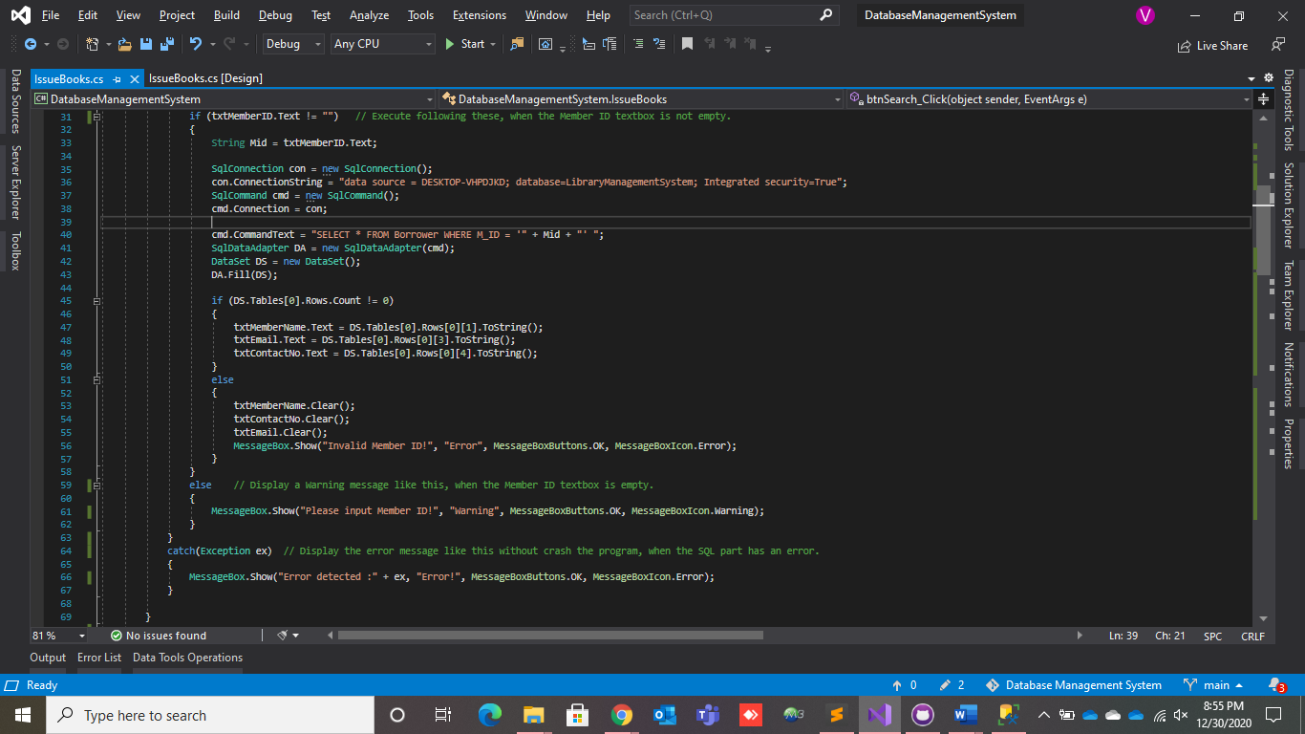

* **When the Book ISBN is entered and after clicked on the ‘Check Button’, this DataGridView shows the Book ISBN, Book name, Book author, Book publish date, Copy numbers related to the entered ISBN and calculate the return date.**

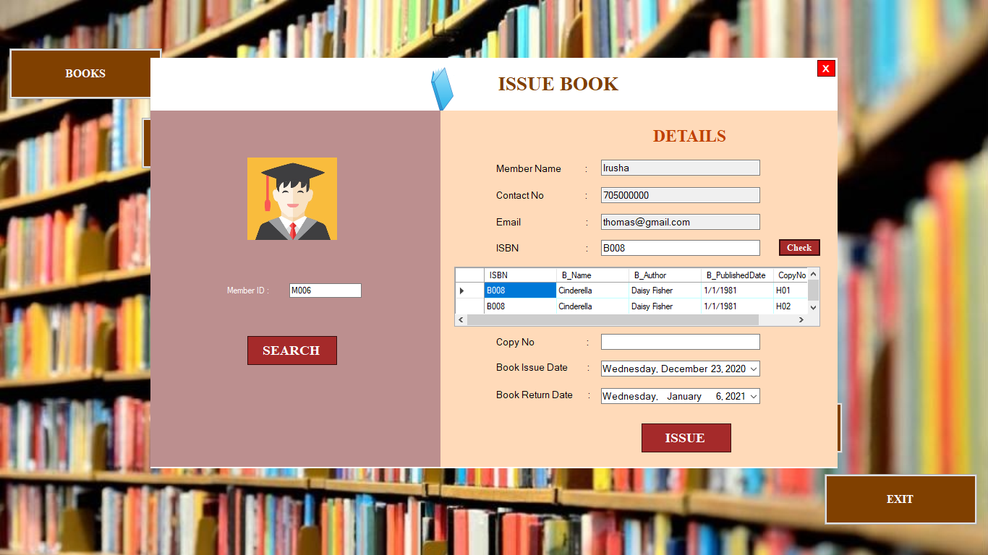

* **This is the coding part of the ‘Check Button’.**

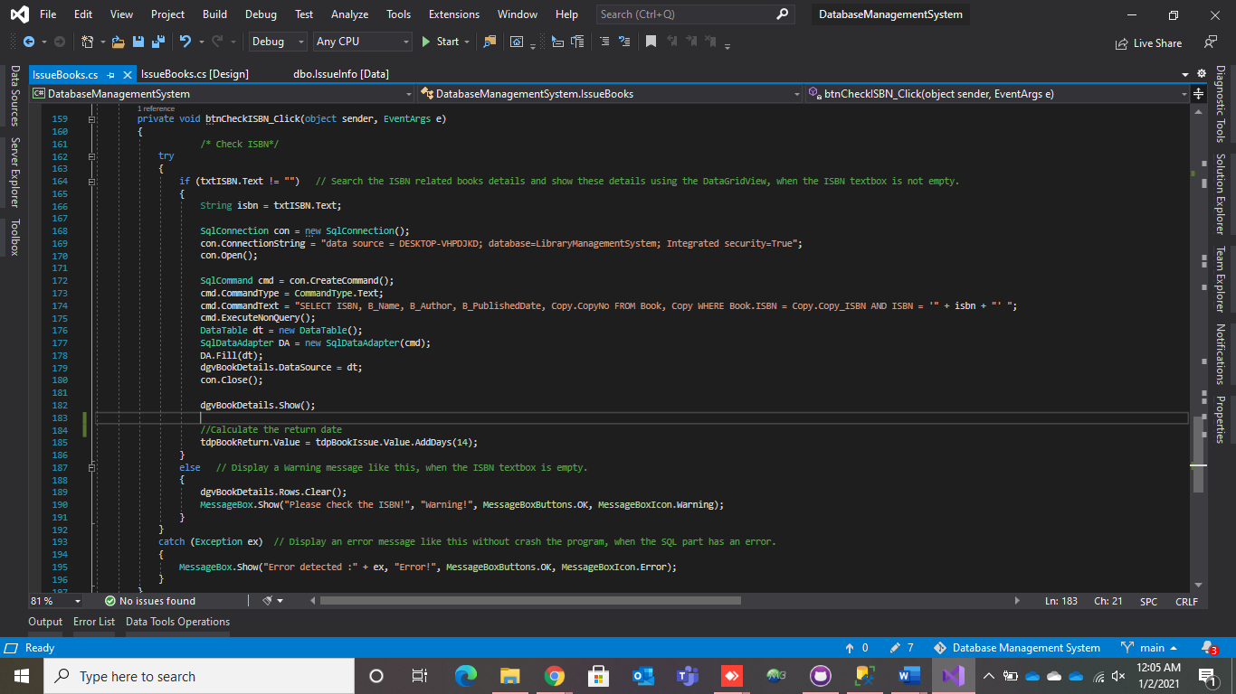

* **When we enter the relevant copy number, the copy will be added to the issue details.**

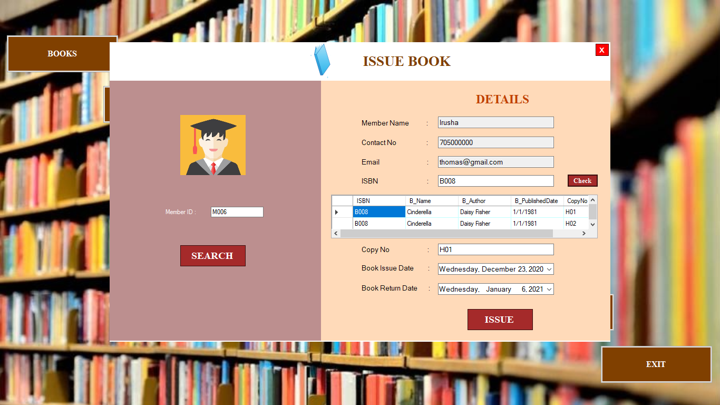

* **After inserted all the details and clicked on the ‘ISSUE Button’, we can issue the relevant book successfully with and close this Issue Book interface.**
* **An issue number will be automatically added for every issue.**

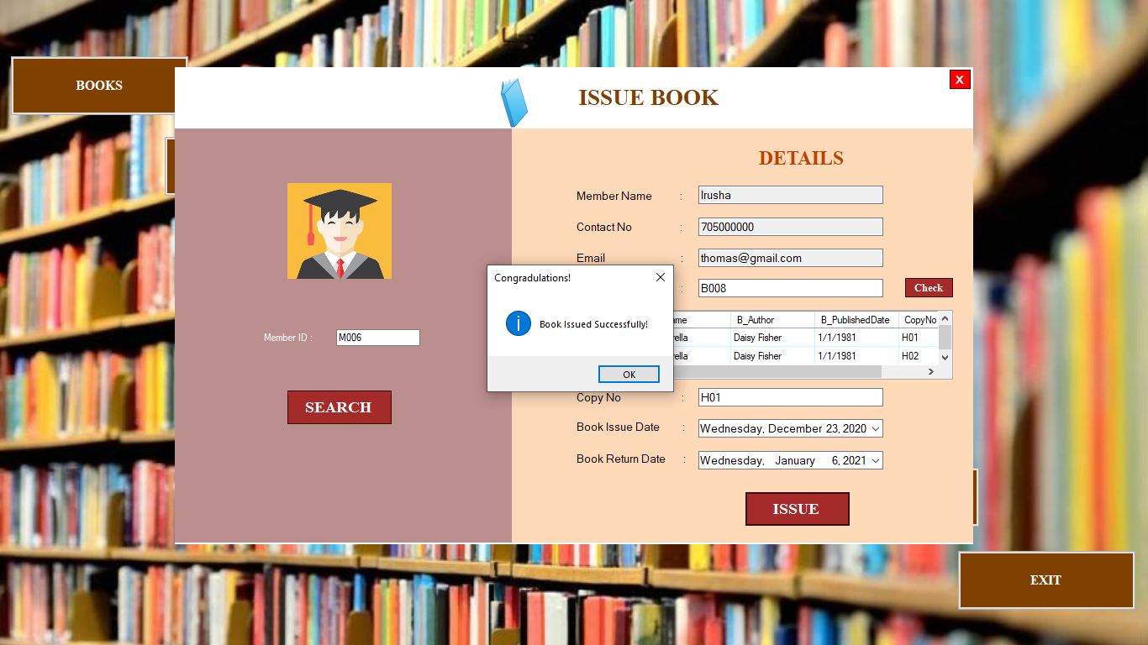

* **This is the coding part of the ‘Issue Button’.**

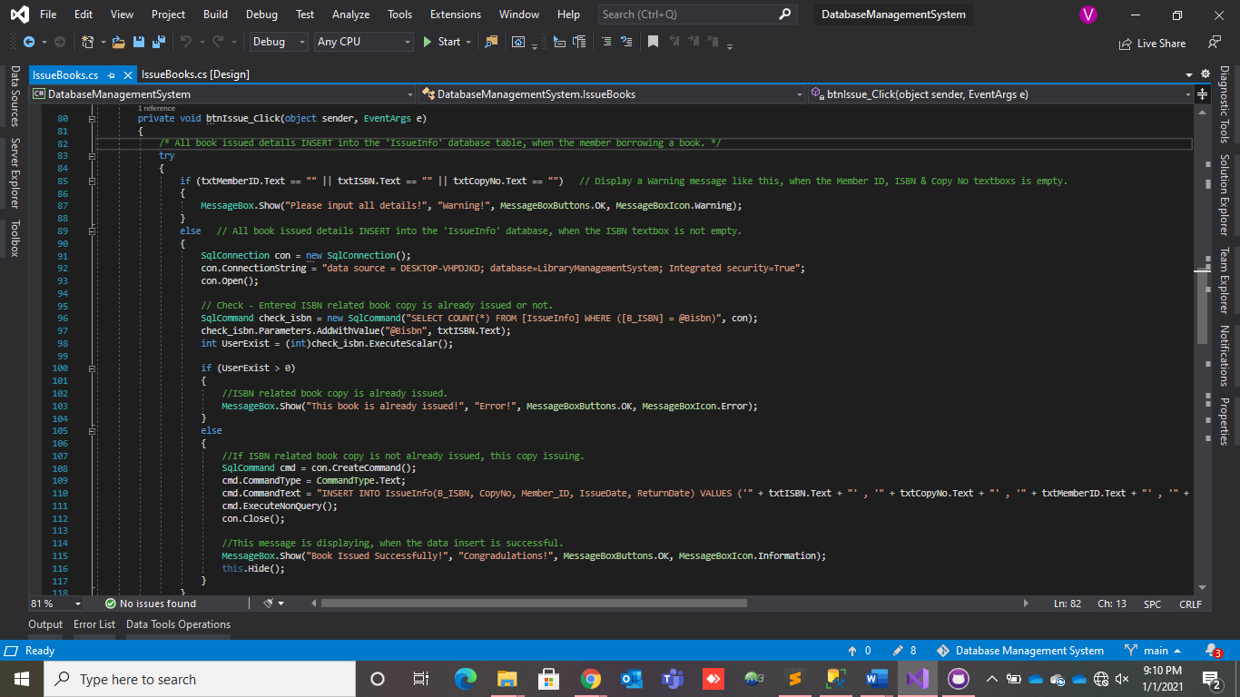 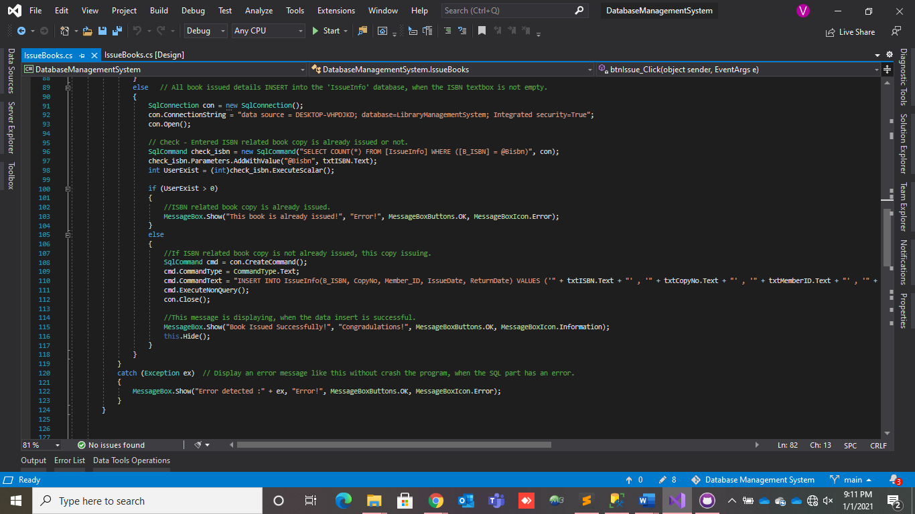

### ERROR MESSAGES

* **Display these error messages using SQL statements with C# language.**
* **Display a warning message like this when the Member ID textbox is empty.**

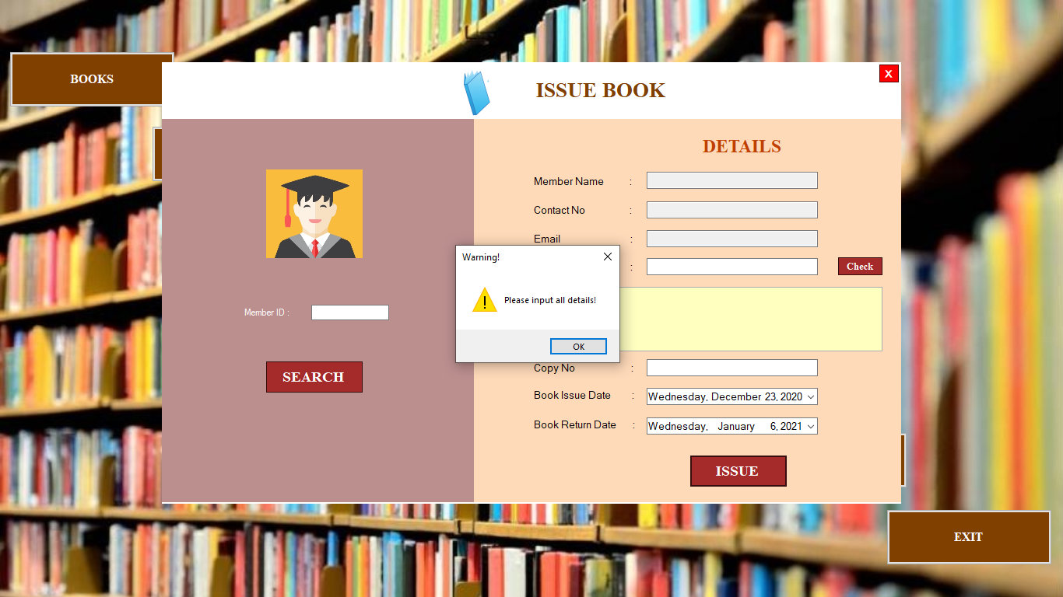

* **Display a warning message like this when the ISBN textbox is empty.**

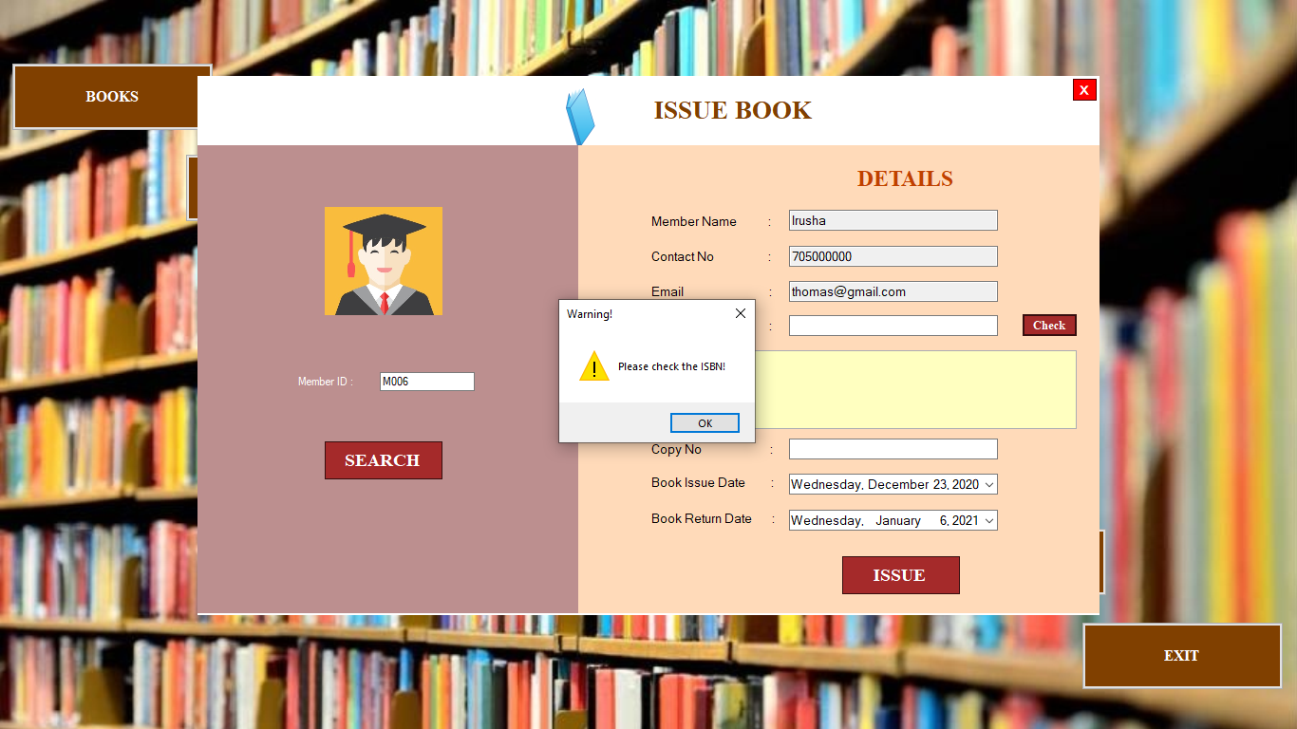

* **Display a warning message like this when the Copy No textbox is empty.**

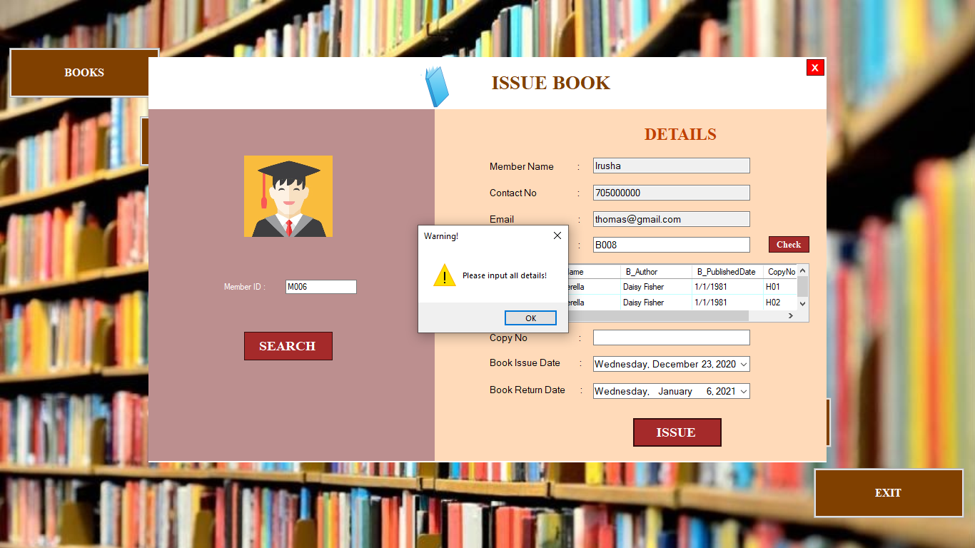

* **If the selected copy number is already issued, an error message will popup.**

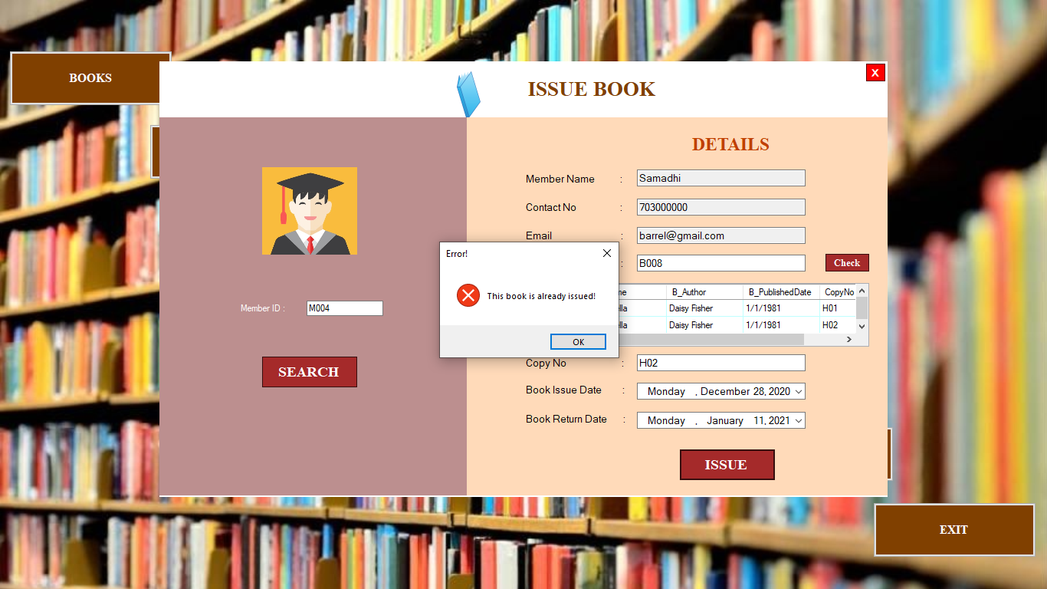

* **If the Member ID is invalid, an error message will popup.**

